Lebanese American University



Capstone Design Project 2

COE – 595 / MCE – 591

Supervisor: Dr. Joe Tekli

Prepared by:

Abbas Abdallah-202101229

Hasan Bazzi 202100867

Mohamad Jaber-202103943

Mohammad Nasser-202102164

# Abstract:

“Ensuring a safe and hygienic environment within hospitals is critical to patient care and infection control.” This belief is incorporated in our project, which focuses finding a solution to decrease human intervention to contagious and dangerous areas in hospitals. Room sanitizing and delivery work are of the most common daily tasks hospital staff are subjected to. However, doing this work in rooms where there are high chances of disease spread puts them under danger. Therefore, we aim to solve this issue by creating an autonomous robot that navigates through the hospital handling those simple, yet essential, tasks. This report highlights the research, design, and the requirements to implement a multi-tasking autonomous robot that navigates through a hospital, acquires several sanitizing methods, and decides to use the most suitable cleaning technique under the available conditions, along with doing the delivery tasks.

Table of Contents

Abstract: 2

1. Introduction: 12

2. Background 13

2.1 Definitions and core concepts 13

2.2 Sanitization and Cleaning Methods 13

a. UV-C Light Disinfection 13

i. How It Works 14

ii. Advantages 15

iii. Limitations 15

iv. disinfection assessment 16

1st method (with no approximations): 16

2nd method (with approximations): 18

b. Wet Mopping 20

i. How It Works 20

ii. Advantages 20

iii. Limitations 20

iv. Best Applications 20

c. Automated Vacuuming 21

i. How It Works 21

ii. Advantages 21

iii. Limitations 21

iv. Best Applications 21

d. Steam Cleaning 21

i. How it works 21

ii. Advantages 21

iii. Limitations 22

iv. Best Applications 22

e. Electrostatic Spraying 22

i. How It Works 22

ii. Advantages 22

iii. Limitations 22

iv. Best Applications 23

f. Ozone Gas Disinfection 23

i. How it works 23

ii. Advantages 23

iii. Limitations 23

iv. Best Applications 24

2.3 Delivery Methods 25

a. Open Tray System 25

b. Color-Coded Drawers 25

c. Compartment-Based Delivery 25

d. Pre-Packed Containers 25

2.4 Navigation Methods: 26

a. Wireless Control 26

b. Localization and Mapping / SLAM 26

i. Odometry based navigation: 27

Concept: 27

Limitations: 27

Solution(s) to Limitation(s): 28

ii. Visual localization and mapping (Visual SLAM): 28

Concept: 28

Limitations: 28

Solution(s) to Limitation(s): 28

iii. Lidar Based Navigation: 29

Concept: 29

Limitation(s): 30

Solution(s) to Limitation(s): 30

2.5. Comparison between options 31

3 Existing Solutions 33

3.1 ‘Xenia: The Medi-Assist Robot’ for Food Delivery and Sanitization in Hospitals [24] 33

Aim: 33

Implementation: 34

Navigation: 34

Delivery: 34

Sanitization: 34

3.2 Robot IRIS 3200 m [6] 36

Aim: 36

Implementation: 36

Sanitization: 36

Significance: 36

Conditions: 37

3.3 Xenex UV-C System [6]: 38

Aim: 38

Implementation: 38

Sanitization: 38

Significance: 38

Conditions: 38

3.4 SANITIZER SPRAYING WIRELESS ROBOT FOR QUARANTINE CENTERS & HOSPITALS [15] 39

Aim: 39

Implementation: 39

Navigation: 39

Sanitization: 39

Significance: 39

Working Principle: 40

3.5 TUG Autonomous Robots 41

Aim: 41

Implementation: 41

Navigation: 41

Delivery: 41

Significance: 41

Working Principle: 42

4. Proposed Implementations 43

4.1. Approach 1 43

4.2. Approach 2 44

4.3. Approach 3 45

4.4. Analysis 45

a. Protection for Individuals and Medical Instruments: 45

b. Delivery Structure: 46

c. Navigation: 46

d. UV-C enhancement: 46

5. Detailed Preferred Implementation: 47

5.1 Sanitization 49

a. UV-C disinfection 49

i. Reason of using it 49

ii. Types of UV-C sanitization 49

iii. Method for enhancement 50

iv. UVC disinfection evaluation 52

v. Limitations and conditions of use 52

b. Vacuum Cleaning 52

c. Mopping 53

5.2 Tray Delivery 53

5.3 Robotic Navigation 54

a. Navigation 54

b. Path Planning 54

5.4 Control 55

5.5 Hardware Plan 55

Initial CAD Model 57

Final Adjusted CAD Model 58

Conclusion 58

System Components 63

Execution Flow 63

Purpose and Safety 64

Conclusion 64

a. Rover and Chassis 66

b. LiDAR Sensor 67

c. Raspberry pi 4 model B 67

d. Vacuum cleaner components 67

e. UV-C lights 68

f. LDR sensor 70

g. Pi Camera 71

h. Power system 71

i. Flip flops 72

j. H-bridge 73

k. Relays 75

5.6 Software Plan 75

**a.** Integration of AI-Based Dust Detection with Raspberry Pi 75

1. Model Architecture and Setup 75

2. Preprocessing Pipeline 76

3. Real-Time Video Frame Processing 77

4. Inference and Prediction 78

5. Raspberry Pi GPIO Configuration 78

6. Triggering the Cleaning System 79

**Model Evaluation:** 79

**Training Accuracy and Loss** 79

**Test Performance** 79

Conclusion 81

a. Robotic Operating System (ROS) 81

b. Localization and Mapping 81

c. Simulation using Gazebo 81

d. Rviz Visualization 82

e. Node and Message Passing 82

f. ROS2 Deployment 82

g. AI Model: 89

Hardware Integration 92

Software Integration 92

Conclusion 93

7.Constraints, Standards, and Cost 93

a. Constraints 93

b. Standards 95

i. Safety Standards 95

ii. Medical and Pharmaceutical Standards 95

iii. Autonomous Navigation and Robotics 95

iv. Performance Standards 95

v. Environmental and Sustainability Standards 95

c. Cost Analysis 96

7. Alignment with the Sustainable Development Goals (SDGs) 97

a. SDG 3: Good Health and Well-Being 97

b. SDG 8: Decent Work and Economic Growth 97

c. SDG 9: Industry, Innovation, and Infrastructure 97

d. SDG 12: Responsible Consumption and Production 98

e. SDG 13: Climate Action 98

f. Other SDGs 98

References 99

Table of Figures

Figure 1 Classification of UV rays, and the significance of each in terms of sanitization [8] 14

Figure 2 different types of DNA damage upon exposure to UV-C [6] 15

Figure 3 Room shape with dimensions [10] 16

Figure 4 User interface of sprinkler sanitizing robot [15] 26

Figure 5 Odometry based localization and mapping [19] 27

Figure 6 Visual SLAM Example [20] 28

Figure 7 Working principle of LIDAR sensor [22] 29

Figure 8 Map of the environment using rviz [23] 30

Figure 9 Location of the robot in the map using rviz [23] 30

Figure 10 Isometric View of Medi-Assist Robot CAD model [24] 33

Figure 11 Path followed by robot during sanitization process [24] 35

Figure 12 Robot IRIS 3200 m [6] 36

Figure 13 Xenex germ-zapping robot with LED xenon bulb [6] 38

Figure 14 Wireless-controlled spraying robot model [15] 39

Figure 15 TUG robots [25] 41

Figure 16 Proposed implementations 43

Figure 17 Activity Diagram of Design 1 43

Figure 18 Activity Diagram of Design 2 44

Figure 19 Activity Diagram of Design 3 45

Figure 20 System's architecture 47

Figure 21 System's activity diagram 48

Figure 22 CAD model of the designed vacuum cleaner 53

Figure 23 CAD model of the system on SOLIDWORKS 55

Figure 24 SOLIDWORKS rendered images of the CAD model from different perspectives 56

Figure 25 New Cad Model 57

Figure 26 Turtlebot and raspberry pi powering circuits 59

Figure 27 UVC lights circuits 60

Figure 28 Mopping pump circuit 61

Figure 29 Pump real circuit 62

Figure 30 Pump Control mechanism 63

Figure 31 Vacuum cleaning circuit 64

Figure 32 Vacuum Cleaner real circuit. 65

Figure 33 Burger and Waffle turtlebot3 [32] 66

Figure 34 Components of the built vacuum cleaner on Solidworks 68

Figure 35 UV-C LED Bulb [33] 69

Figure 36 UVC LED strips [34] 69

Figure 37 UVC LEDs used in project 70

Figure 38 LDR sensor [35] 70

Figure 39 Raspberry pi 4 model B with its camera [36] 71

Figure 40 L293D H-bridge pins [37] 73

Figure 41 Connections of the DC motor with L293D 74

Figure 42Model Evaluation 1 80

Figure 43 Model Evaluation 2 80

Figure 44 Turtlebot3 deployment on gazebo 83

Figure 45 Turtlebot3 insertion in an environment and data collection 84

Figure 46 Defining navigation method 84

Figure 47 Controlling the motion of the robot using the keyboard keys 85

Figure 48 image showing the map on rviz at initial state before navigation 86

Figure 49 image showing the entire world on gazebo 86

Figure 50 image showing the updated map on Rviz after completing the navigation over the house 87

Figure 51 image of setting pose estimate 88

Figure 52 image of setting the navigation goal 88

Figure 53 robot reaching its navigation goal on gazebo 89

Figure 54 Full Working Sysem 91

Table of Tables

Table 1 table of comparison of each section 31

Table 2 Comparison of different types of UV-C light sources [3] 49

Table 3 Limitations of UV-C disinfection and their solutions [3] 50

Table 4 Comparing methods of UVC disinfection assessment 52

Table 5 Difference between turtlebot models [31] 63

Table 6 Table of Constraints 90

Table 7 Table of components and costs 93

# 1. Introduction:

With the increased demand for high standards of hygiene and health care, there is a growing interest in solutions that will manage both environmental sanitization, and accurate delivery in health care and hospitality, among other sensitive environments, especially during critical times where there is widespread of some contagious diseases. Traditional robots in hospitals are usually known to be non-optimal, whether in the sanitization technique that does not ensure full coverage of areas with proper disinfection, or in delivery that needs to be done accurately and timely. These are particularly crucial issues in areas where the patients must be exposed to minimum levels of the pathogen, and medication accuracy must be at its maximum.

This project describes the research and requirements needed to develop an autonomous sanitization and delivery robot by providing its design, state of art, and working constraints. The proposed robot will be capable of independent traversal through a complex indoor environment while carrying out comprehensive disinfection using UV-C lights, mopping, and vacuum cleaning mechanisms. With the use of sophisticated mapping technologies such as LIDAR, the robot will automatically find areas to be sanitized and perform effective disinfection with minimum human interaction to prevent further contamination or human exposure to danger. Regarding the delivery, the robot will be delivering food to patients in specified rooms, as well as medications that can be delivered without the need of any special conditions on their delivery. The robot is instructed with the sanitizing and delivery tasks by a supervisor that will be orchestrating the robot’s movement, scheduling the tasks, and assigning the destination of the robot.

The robot uses ROS for autonomous control and navigation, advanced sensor integrations for real-time mapping and obstacle avoidance, and a user-friendly interface that makes it easy to interact with the system by healthcare staff. Safety is assured through the usage of motion detectors that stop disinfection processes in case any human presence is detected to avoid UV-C light exposure. This dual-function autonomous system shows great promise for simplifying operations, enhancing hygiene, and thereby helping with reliable drug delivery for an efficient and safe environment in medical applications and other areas where sanitation and precision are prime factors.

The rest of this report is structured as follows. Section 2 provides background and existing literature on automated sanitization and medication delivery technologies. Section 3 discusses the existing state-of-the-art solutions and their deficiencies. Section 4 introduces our project proposal. Section 5 describes how we will implement our proposed work. Section 6 talks about the constraints and standards that guide us through our project. Lastly, Section 7 discusses some future work and possible improvements.

# 2. Background

## 

## 2.1 Definitions and core concepts

For many years, disinfection has remained a cornerstone for public health measures in healthcare and places that attract large volumes of people. Many methods have been employed in this regard. Starting with the traditional method which is human cleaning. This method incorporates some drawbacks such as being suboptimal and that staff might misuse disinfectants [1]. Other methods exist such as spraying and using sprinklers. Even though this method has shown to be reliable in disinfecting pathogens but might still cause corrosion to hospital material which is affects the decision of considering them significantly [2]. However, UV-C light disinfection remains one of the most effective methods, given its germicidal properties [1] [3] [4] [5] [6].

It is against the background of these challenges, associated with incomplete manual cleaning, that the development of autonomous UV-C disinfection robots has been considered. These robots combine UV-C lamps with navigation and obstacle avoidance systems, enabling them to clean harsh environments effectively with minimal human labor. Such robots are very important in reducing infection risks in hospitals, schools, and public places during pandemics such as COVID-19.

In addition to sanitization and cleaning, the robot can be designed to tackle delivery tasks. This can be designed using open tray compartments or dedicated shelves designed to hold food for patients. The use of a tray system allows for quick adding and removal of food, making it very useful in hospitals. This approach ensures smooth navigation, user –friendly interfaces, minimal human intervention, and efficient meal distribution, which reduces chances of errors.

## 2.2 Sanitization and Cleaning Methods

### a. UV-C Light Disinfection

UV-C light has been adopted as one of the most effective disinfection approaches within hospitals and public areas. UV light emits ultraviolet light ranging from 200 to 280 nm in wavelength, which modifies microbial DNA or RNA through photochemical reactions; these processes disrupt the replication of microbes, hence incapacitating the pathogens.

#### How It Works

UV-C Light disinfection involves the installation of UV-C lamps that emit rays within a certain range of wavelength, generally could be any wave length between 200 nm and 280 nm, which essentially destroys microorganisms. When the rays hit the pathogen, they target the DNA or RNA destroying them leading to disinfection [3] [7]. Mounted on an autonomous robot, such lamps enable the system to navigate through space and expose surfaces to the germicidal light for uniform disinfection across the exposed area. The significance of using UV-C rays as disinfectants rather than other UV rays is highlighted in the figure below:

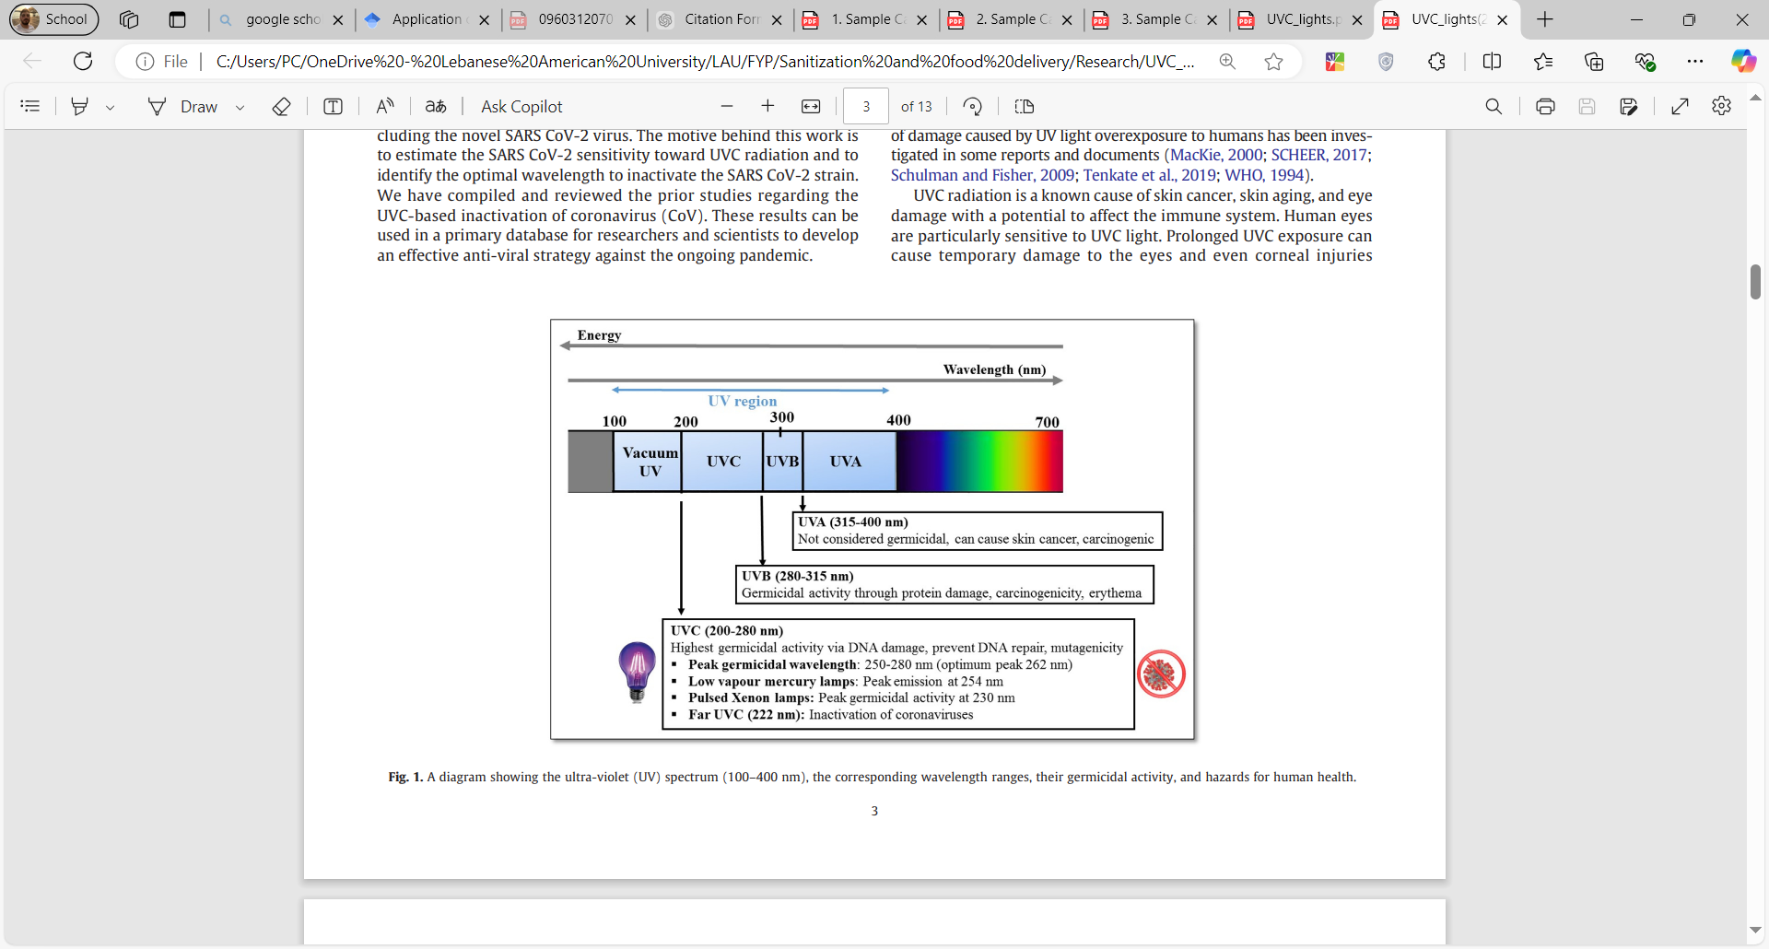

Figure 1 Classification of UV rays, and the significance of each in terms of sanitization [8]

Fig. 1 shows the different types of UV rays. It can be seen that as the wavelength of the UV rays decreases, the energy of those rays increase. And thus, the rays are able to be more efficient in terms of sanitization. Therefore, the target in disinfecting applications is the use of UV-C rays which are the most efficient of their type.

As for the biological aspect, what really happens due to the exposure to UV-C lamps is that the DNA of the microbe/pathogen gets damaged. The damage could be classified into 4 different types represented in Fig. 2. The first type is photohydration. It is represented by pulling water molecules into the DNA that prevents transcription. The second type is photosplitting which is the break of the backbone of the DNA. The third type is photodimerization which causes an improper connection between DNA fuses preventing cell replication. And the final type is photocrosslinking which causes cell wall damage. Any type of those damages disallows the cells of the pathogen to regenerate and repair [6].

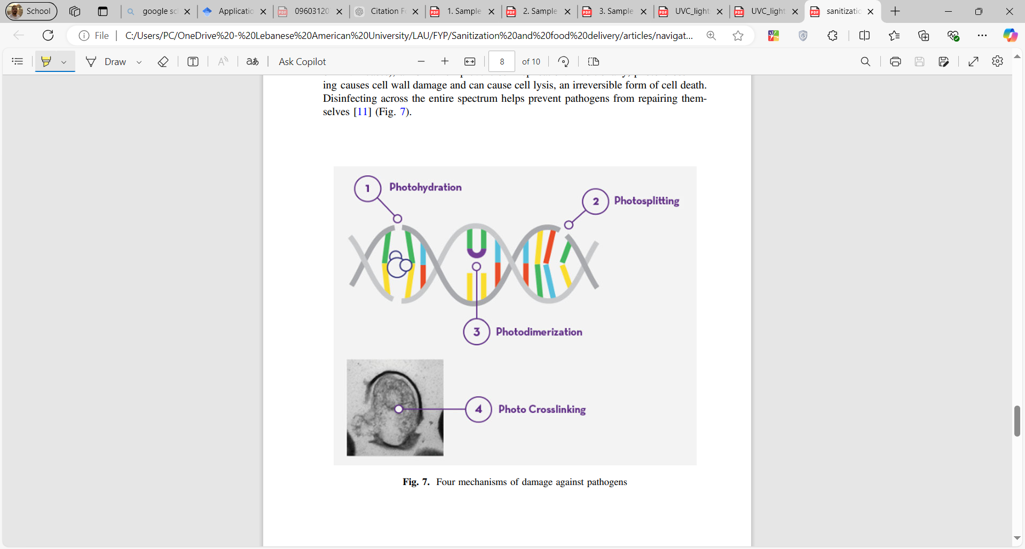

Figure 2 different types of DNA damage upon exposure to UV-C [6]

#### ii. Advantages

High Efficacy: UV-C light is able to inactivate up to 99.99 percent of bacteria, viruses, and other kinds of pathogens [5] [1].  
Non-chemical: It avoids the use of strong chemicals, hence it is ecologically friendly and does not leave any residue [9].

iii. Limitations  
Despite its effectiveness, UV-C light also has certain limitations:

**Areas Kept in Shadow:** The clear light is able to disinfect only those areas on which it directly falls. The regions that remain shadowed or covered cannot be treated and may harbor the pathogen [4] [10].

**Safety and Surface Risks:** Long-term exposure to UV-C can degrade surfaces [4] [3] and create risks to people through skin burning or eye injury [3] [2] [7], aside from health problems due to ozone production [4] [3] [5] which itself may require specific operational controls.

**Risk of material damage:** If the UV-C rays are being used in a dose that exceeds the threshold sustained by some type of material present in the surrounding, the material might get damaged [3] [4].

**Not able to penetrate dirt:** The UV-C rays do disinfection of the atmosphere and surfaces, however, surfaces having over them dirt are not sanitized since the dirt is forming a cover [3]. This issue can be solved by doing pre-cleaning before UV-C disinfection.

**Best Applications**  
Due to this fact, UV-C light is very well adapted in highly sensitive environments such as hospitals, schools, office spaces, and public transport, where microbial contamination reduction is crucially important for disinfecting exposed surfaces.

#### iv. disinfection assessment

##### 1st method (with no approximations):

It is unclear about the required dose of UV-C light in order to do a complete disinfection [3]. To illustrate, each pathogen can be disinfected upon being subjected to a specific dose, under a specific intensity, and for a specific time. To illustrate, [5] provides different examples of viruses and bacteria, showing the needed time to disinfect them under a specific dose. In fact, we intend to come up a with a method that generalizes all cases, giving the needed time to do complete sanitization under a specific UVC dose. To do this we use the work presented by [10].

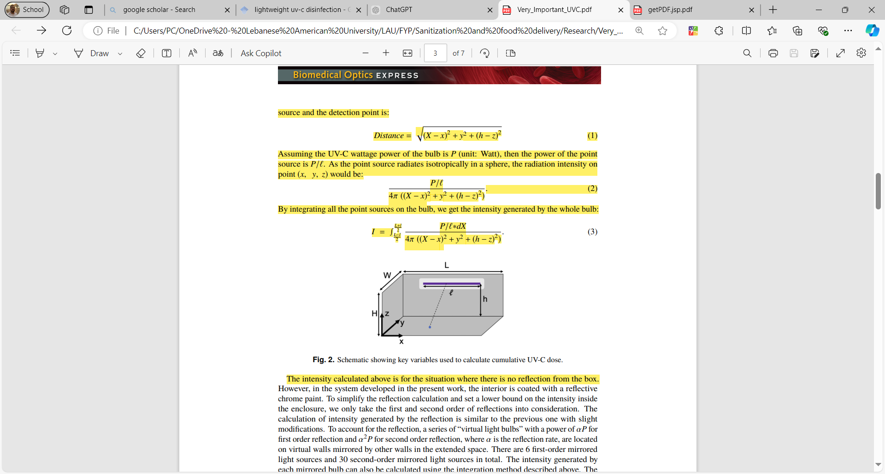

Figure Room shape with dimensions [10]

The authors in [10] have stated the intensity of light through the rectangular room presented in Fig. 3, and in case the light source is in the same shape it is placed at (in the x direction), and is stationary. The location of any point source on the bulb can be expressed as (X, 0, h), where X ∈ [(L−l)/2, (L+l)/2]. For any point (x, y, z) in the room, the intensity emitted on the point in the room is:

Equation Intensity of UVC for a horizontal stationary light source with no reflections [10]

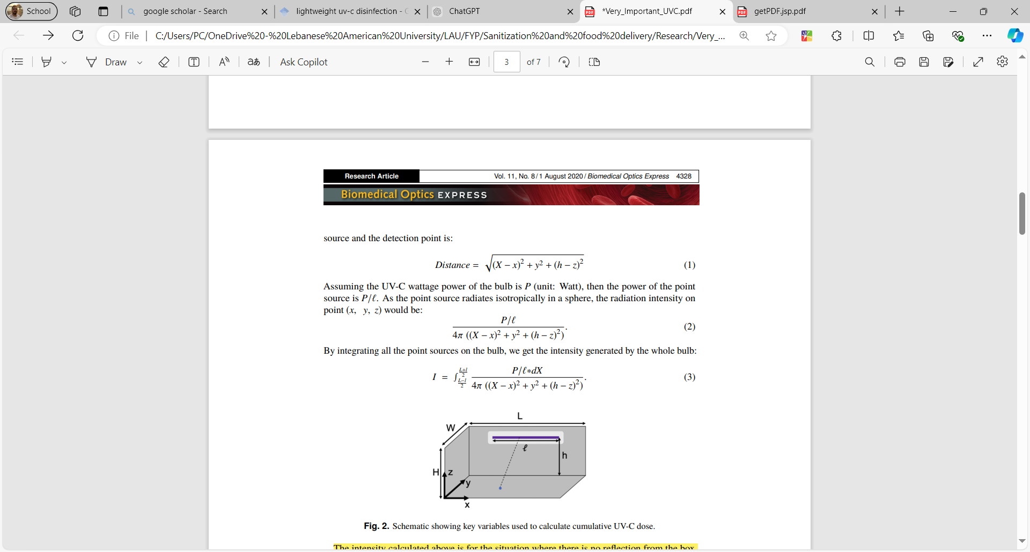

Equation Intensity of UVC for a horizontal stationary light source with reflections [10]

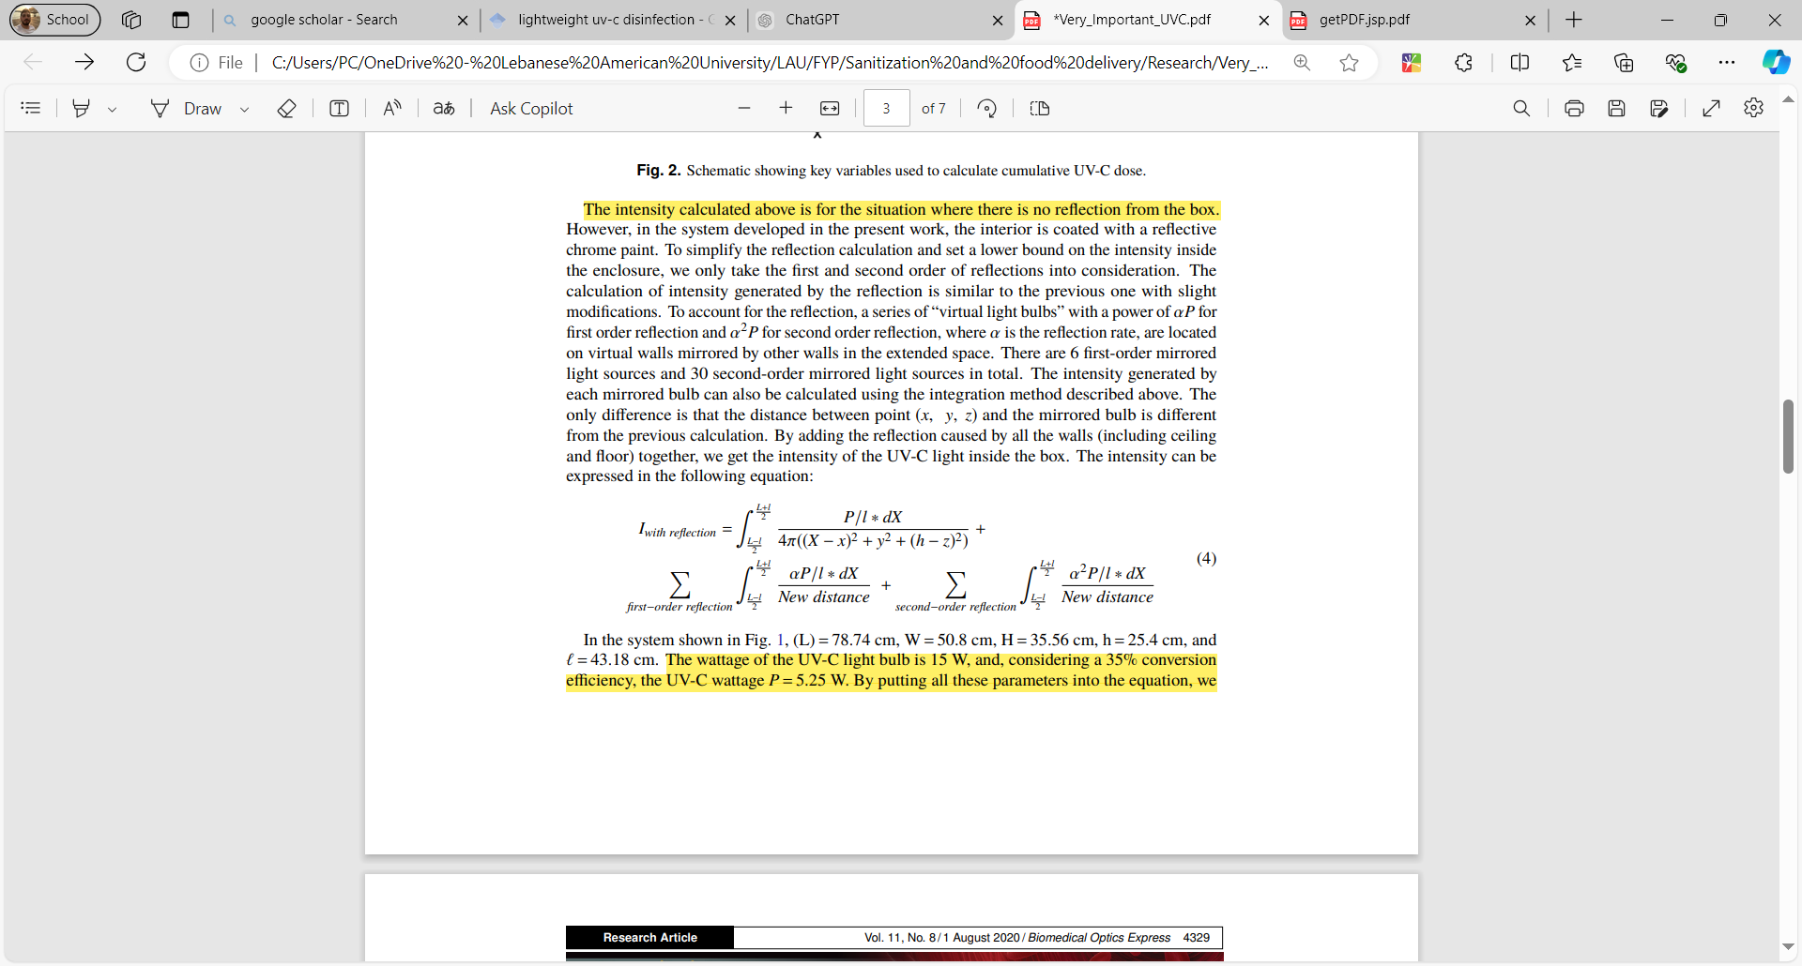

Looking into the equations provided above, they seem to be logical as the integration is done over the light source length ‘l’, the light source is placed in the XZ plane with coordinates (X, 0, h), and where ‘P’ represents the power provided by the light bulb. In the case of reflection, the term $α$ corresponds to the reflection rate.

In case, the light source is not in the stationary in the XZ plane, and is to move in the XY plane then the term becomes (Y-y) and the variable is dxdy and not only dx, since the light source spreads over the X dimension, and spreads over the Y direction (it has a length and a width to be considered). The **average** intensity in this case is:

$$I=\frac{1}{LW}\iint_{0 0}^{L W}{\frac{\frac{P}{l}}{4π({\left(X-x\right)}^{2}+{\left(Y-y\right)}^{2}+{\left(H-z\right)}^{2})}dx dy}$$

Also, looking into the formulas stated, the light source is horizontal, in case it was placed vertically, that is in the z direction instead of x direction:

* Integration along the height from 0 to h which is the height / z’ elevation of the light bulb (the case where the light source has its bottom in contact with XY plane that is its z’ = 0, and its extreme of z’ = h). But z inside the interval itself in the room can vary from 0 up to H which is the total height of the room. To illustrate,
$$I\left(x, y, z\right)= \int_{0}^{h}{\frac{\frac{P}{h}}{4π({\left(X-x\right)}^{2}+{\left(Y-y\right)}^{2}+{\left(z^{'}-z\right)}^{2})}dz'} z∈\left[0,H\right]$$

* Then now, we can integrate over the whole room:

$$I\left(x, y, z\right)=\frac{1}{LW}\iint_{0 0}^{L W}{(}\int_{0}^{h}{\frac{\frac{P}{h}}{4π({\left(X-x\right)}^{2}+{\left(Y-y\right)}^{2}+{\left(z^{'}-z\right)}^{2}}dz'}) dxdy z∈\left[0,H\right]$$

Notice the numerator is P/h and not P/l since the light bulb is put in z direction and not x direction. Another thing is in case of reflection, add to this term the other term corresponding to the summations and $α.$ Since we introduce reflections to our application, then the formula to be used when assessing the average intensity at each point in space is:

$$I\left(x, y, z\right)=\frac{1}{LW}\iint_{0 0}^{L W}{(}\int_{0}^{h}{\frac{\frac{P}{h}}{4π({\left(X-x\right)}^{2}+{\left(Y-y\right)}^{2}+{\left(z^{'}-z\right)}^{2}}dz^{'}}) dxdy$$

$$+$$

$\sum_{n=1}^{N}{\frac{α^{n}}{LW}\iint_{0 0}^{L W}{(}\int_{0}^{h}{\frac{\frac{P}{h}}{4π({\left(X-x\right)}^{2}+{\left(Y-y\right)}^{2}+{\left(z^{'}-z\right)}^{2}}dz'}) dxdy } z∈\left[0,H\right]$

In our case as mentioned, we are using Microporous PTFE reflective material reflecting more than 60 % of the UVC light, therefore, $α ≈0.6$ in our case, and at its minimum.

Remark: In case of rooms that have curvature, then transforming into cylindrical coordinates or other methods of integration might be easier to calculate the intensity at each particle of the room.

In our case, since we have introduced reflection into our system,

This was regarding the intensity, however this might not be very practical as the hospital staff might not understand what is intensity, thus we present the following formula relating dose, intensity, and time:

$D\left(x, y,z\right)=I\left(x, y, z\right) . ∆t$ [3]

The formula above shows that by knowing the intensity of UVC, and the dose needed to disinfect a certain pathogen, we can get the time needed to do disinfection for this specific pathogen. It is important to state that there tables given by standards showing the required dose to disinfect some pathogens, and thus by using them we can calculate the time needed to do the disinfection.

##### 2nd method (with approximations):

Disinfection is usually modelled in terms of the survival or even in terms of the inactivation rates of microorganisms.

**Dose = (irradiance).(exposure time)**

Where, D is in J/ $m^{3}$, time in sec, and Irradiance in W/ $m^{3}$

The second method serves as an assumption-based method where we assume that the intensity is uniform over the room and approximate it to be:

$Intensity=\frac{Power}{Volume}$

By using this formula, and using the dose in tables, we can get the time needed for disinfection.

Now as a matter of assessing the percentage of disinfection achieved, there exists a relation that relates the initial number of microorganisms, final number, dose, with some constant k represented as:

$ln\left(\frac{N}{No}\right)= -k.D$ [11]

N is the final number of microorganisms, No is the initial number, D is the dose of UVC used, and k is microbial inactivation rate constant determined by experimentation. A brief explanation about how to get k is through:

1. Perform experiments at various UV doses (D = I.t) by changing the exposure times or intensities.
2. Measure the survival fraction of microorganisms (N/No)
3. Obtain a dataset of survival fractions (N/No) from multiple experiments each under different dose.
4. Use the first-order kinetics model: $ln\left(\frac{N}{No}\right)= -k.D$
5. Use linear regression on the data to obtain the slope –k of the line.

**Remarks:**

* **k is species specific, so each microorganism has its own specific k. Also, k varies according to temperature and humidity since the N/No differs according to such factors.**
* **N and No can be determined experimentally by the use of bioindicators. They are themselves microorganisms (or spore-forming versions such as Bacillus subtilis). Those indicators are biological entities used to directly measure microbial viability through CFU counts** [12]**.**

As for the disinfection rate, it is logical to have it as $R=\frac{No-N}{No}=1-\frac{N}{No}$

And so now, after having the first-order kinetics model equation, and the formula of disinfection rate, we can do several adjustments:

🡺

Therefore, we can use the dose with the variable k to get the disinfection rate.

However, the final formula of disinfection rate is limited and is applicable over a specific conditions, which are:

* Uniform dose distribution across all surfaces, so the objects far from UVC and close to UVC are assumed to consume the same dose for instance.
* The humidity and temperature are all constant and do not change in the room.

However, with those assumptions taken, assessment is facilitated and much easier to be calculated.

### b. Wet Mopping

Wet mopping is one such practice indicated for floor surfaces in terms of sanitizing and cleaning. This practice is considered important, especially in high-traffic areas where different diseases or microorganisms can easily spread. The procedure involves the application of cleaning solutions onto the floors for loosening the dirt and contaminants, which would later be scrubbed off efficiently [13]. It was proven that hydrogen peroxide is a common disinfectant that is usually used in spraying mechanisms [4] [1]. Therefore, in our approach we aim to combine the use of this disinfectant with the mopping mechanism to clean and hygiene the floor.

1. How It Works

The Robotic Wet Mopping System automates all this by incorporating a solution dispenser into a mechanism for scrubbing. For instance, there is some type of sponge that can be held by the robot and touching the floor. The sponge rotates and scrubs the floor by the time it is fed with hydrogen peroxide solution at some intervals of time. With this, we can make sure the floor is cleaned and also disinfected similar to the implementation in [13].

#### Advantages

The work of robotic mopping systems minimizes manual labor and ensures consistent results in terms of disinfection.

1. Limitations  
    Although wet mopping is effective for cleaning floors, it does have a few drawbacks:

* **Limited Scope:** This method is focused on floor surfaces and does not address airborne pathogens or contaminants on elevated surfaces.
* **Residue Issues:** It might leave residues behind.

#### Best Applications

Since floor requires thorough and frequent cleaning wet mopping is helpful in crowded environments in hospitals such as corridors, floors of operational room and others.

### c. Automated Vacuuming

Vacuum cleaning removes dust, dirt, and debris. This reduces the presence of microbial habits which prepares the surface for more effective sanitization process. In most cases, this method is combined with mopping as in [13].

1. How It Works

It collects powder dust from floor surfaces by using advanced suction technology.

#### Advantages

* **Improving Pre-Sanitization** by removing loose particles.
* **Reliable and Efficient** where they operate independently, cleaning large areas with consistent results and reducing the need for manual labor.

1. Limitations

Despite their usefulness, automated vacuuming systems do have some constraints:

* Vacuum cleaning do not sanitize surfaces, it just cleans dust from floor, instead of having staff to sweep the floor.
* Vacuum cleaning are better for hard surface where they can struggle with carpets or uneven flooring.

1. Best Applications

Automated vacuuming is particularly effective for pre-sanitization in busy environments such as hospitals, offices, and homes. By removing visible dirt, it helps prepare floors for thorough disinfection, ensuring cleaner and safer spaces.

### d. Steam Cleaning

#### i. How it works

It begins with water that is heated in a steam generator (typically contained within a robotic cleaning system). This type of generator changes water to steam and the steam is out there will then be use on mismatched surfaces. The extreme temperature kills any bacteria, viruses and other pathogens to sanitize the space [13].

#### Advantages

**No Chemicals Solution:** Steam cleaners do not use or need a lot of harsh chemicals, so they are safe to use, environmentally friendly and there is no antibacterial residual follow-up.

**Uniqueness:** This method is applicable to all hard surfaces and heavy-duty devices such as applying them to curtains as in [13].

#### Limitations

Steam cleaning is very powerful but it does have its limitations:

**Inappropriate for Fragile Items:** The extreme temperate levels might be dangerous to fragile commodities or undermine sensitive machinery [14].

**Limited Surface Application:** Hot and moist the atmosphere is not supposed to be used on all surfaces [14].

#### Best Applications

It's ideal for disinfecting hard surfaces and equipment in situations like hospitals, laboratories or industrial environments. This is especially useful in areas where deep, detergent free cleaning is required to maintain hygiene.

### e. Electrostatic Spraying

Electrostatic spraying makes for an extremely useful, forward-looking sanitizing approach. This method utilizes disinfectant particles that are electrically charged to achieve complete surface coverage. It’s most effective when it comes to the sanitization of large surfaces and when working within highly complex environments where cleaning has to be done in hard to reach places.

#### How It Works

The system works by subjecting a stream of disinfectant particles to a charge as they are funneled through a specially designed nozzle. The particles form a fine aerosol mist that has surface adjunctive properties so that it can reach difficult areas and surfaces to ensure the disinfectant is applied in an even manner for maximum compatibility [15].

#### Advantages

**Thorough Coverage:** The charged particles adhere uniformly to the surface even in corners and deep seals.

**Efficient Use of Disinfectant:** With this method, more area can be covered in a short time and less disinfectant when compared to the traditional methods.

#### Limitations

However, there are also some limitations that electrostatic spraying procedures are faced with, which are as follows:

**Consumables Dependency:** Operating costs may be high as there is the need to refill the disinfectant on a consistent basis [15].

**Risk of Residue:** Excess use or use of low-quality electrostatic spraying could result in residue on surfaces which may not be appropriate for use in certain environments [2].

#### Best Applications

The method is great for large surface areas and complex designs such as schools, hospitals or industrial plants.

### f. Ozone Gas Disinfection

Ozone gas disinfection is a technique for the eradication of microorganisms, both pathogens that are suspended in the air and those that are on more inaccessible areas. This technique utilizes the oxidizing potential of ozone in such a way that it enables the sterilization of surfaces with no chemical substances.

#### How it works

Ozone gas disinfection is done with a machine known as a generator which often comes as a component of robot systems. After being emitted, ozone reacts with microorganisms by invading their cell walls through oxidation, which disintegrates their structures. In this way, ozone is able to inactivate many pathogens making ozone gas ideal for use in areas difficult to clean using the conventional cleaning methods [16].

#### Advantages

**Broader Coverage:** Ozone gas has strong impact in disinfecting calm air and hard-to-reach and concealed surfaces during disinfection [17].

**No Chemicals Used:** As with liquid disinfectants, for example, ozone leaves no chemical residue behind which makes it a better choice [17].

#### Limitations

Nevertheless, there is some complexity involved with some of the approaches, ozone disinfection being one of them:

**Health Concerns:** Ozone is very toxic to animal and human life and therefore lets only the operators remain in the area of interest during the procedure [18].

**Operational Conditions:** There are certain procedures for each treatment including the need to cover the area to be disinfected and allow aeration before returning to the premises [18].

#### Best Applications

Ozone gas disinfection works best in controlled environments like unoccupied hospital rooms, and sealed storage spaces. In addition, Ozone gas disinfection can sterilize both air and surfaces which makes it a beneficial solution [16].

## 2.3 Delivery Methods

### Open Tray System

**How it works:** Robot has open trays or shelves where meal boxes or dishes are placed, so users can access them easily.

**User Interface:** Touch screen guides user to select their meal, with visual indicators pointing to the correct tray or shelf.

### Color-Coded Drawers

**How it works:** Drawers are color coded for different meal options or dietary categories (e.g. vegan, gluten free).

**User Interface:** Screen lights up the corresponding drawer based on the selected meal, so user can’t go wrong.

### Compartment-Based Delivery

**How it works:** Pre-labeled compartments hold food items by order number, time or user ID.

User Interface: Screen shows user’s name or order number, and compartment opens when user confirms their selection.

1. Pre-Packed Containers

**How it works:** Meals are pre-packaged in individual, easy to carry containers stored in robot compartments.

**User Interface:** Robot shows user’s name or table number, and user can just grab their meal from the designated area.

## 2.4 Navigation Methods:

### a. Wireless Control

In this method, the robot is controlled remotely by some supervisor using a UI. In fact, a UI is made, and using some modules such as HC-05 Bluetooth module placed on the robot, the robot can be controlled remotely in the needed direction. [15] has used this method to control the navigation of their sanitizing robot, and the built interface is represented as follows in the fig. 4 below:

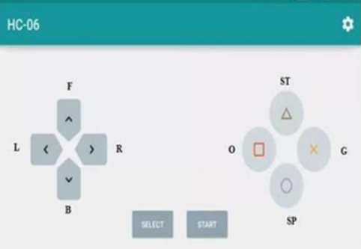

Figure User interface of sprinkler sanitizing robot [15]

The given example was one scenario of Wireless/Bluetooth control. There are various methods to implement such a remote working system, and can be done on different types of controllers such as Arduino, Raspberry pi serving as a controller, Jetson nano serving as a controller … Regarding the control system, it is to be managed aside by some method. For instance, the navigation works on a separate system from the control, and they are not developed in the same environment.

### b. Localization and Mapping / SLAM

This method is one of the navigation methods used for an autonomous robot. It is based on working with Robotic Operating System (ROS) mainly. This method serves as teaching the robot about the environment, helping the robot coordinate specific points in the environment, as well as locate itself in its working area. So generally, it is based on coordinates. It is important here to differentiate between SLAM and between localization and mapping. SLAM refers to simultaneous localization and mapping where the robot is let to navigate through an environment it does not know, and therefore the robot is navigating and using this information collected while navigation to build a map for the environment at one shot. On the other hand, localization and mapping refers to having the map of the environment already predefined for the robot, so the robot has the map for the environment, and the robot is let using its knowledge of the map, and using the sensor information to navigate and localize itself in the environment. Different approaches branch from the title of navigation varying from:

#### Odometry based navigation:

##### Concept:

In this method sensors such as encoders for the DC motors in the wheels are used, by which we track the movement of each wheel and thoroughly we can predict to which direction the robot is going, and in which speed, relative to some reference point. Indeed, a reference point is taken, and we do kinematic modeling of the system and do calculations to estimate the position of the robot relative to its reference point. To elaborate, and in case where we constrain the focus on localization and mapping rather than SLAM, the robot as it navigates, it has some estimate position, and it compares this estimate position that is based on the equations formed and the data collected from sensors for example like IMUs or encoders, with its actual real position that is from the predefined map. With this, the robot can fix the error by introducing some cost function.

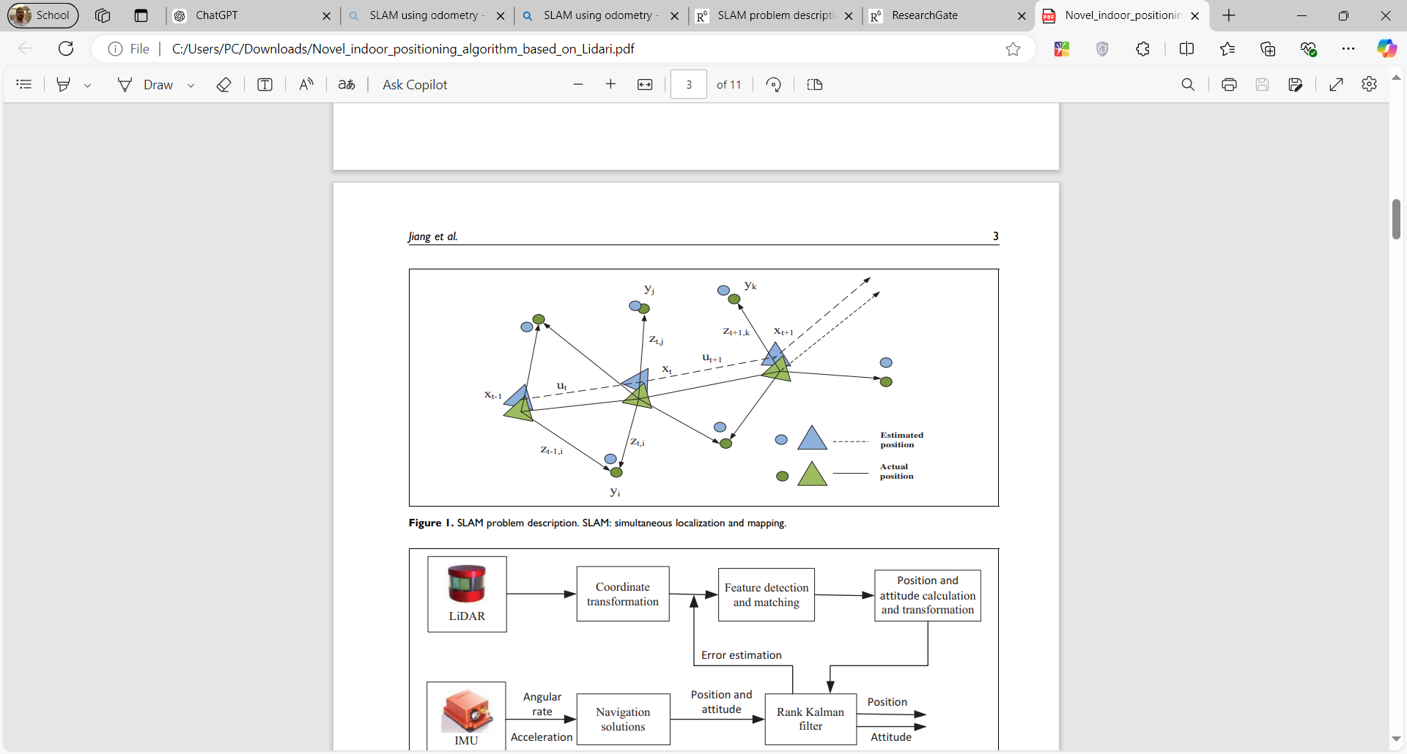

Figure Odometry based localization and mapping [19]

Fig. 5 shows the position the basic concept of the odometry based method for navigation. There exist some landmarks in the environment, they are represented by circles. And there is the robot’s position represented by triangle. The robot moves from the from $x_{t-1}$ to $x_{t}$ then to $x_{t+1}$. After each movement of the robot, the actual position of the landmarks $(z_{t,j}, z_{t-1, i}, z_{t+1, k})$, and the estimated position of the landmarks ($y_{j}, y_{i}, y_{k})$ are calculated. Similarly, the actual position of the robot, is compared to the estimated position of the robot.

##### Limitations:

This method if does not try to solve errors, accumulates them leading to inaccurate readings as the robot proceeds with navigation. Indeed, it can be seen in Fig. 5 how the robot drifted from the correct readings, and since this problem was not solved, this error accumulates with further errors that might arise as the robot proceeds, leading to more drift. To elaborate, it can be seen that the drift of the landmark positions (green and blue circles) is increasing as the robot proceeds.

##### Solution(s) to Limitation(s):

Regarding the solution, we can consider using a cost function a solution where the robot penalizes errors.

#### Visual localization and mapping (Visual SLAM):

##### Concept:

Other methods include visual localization and mapping through the use of RGB-D cameras like the MS Kinect. In this method, the robot is trained visually on its surrounding, and is able from the visual features extracted from the cameras to localize itself, and know how to proceed to the destination.

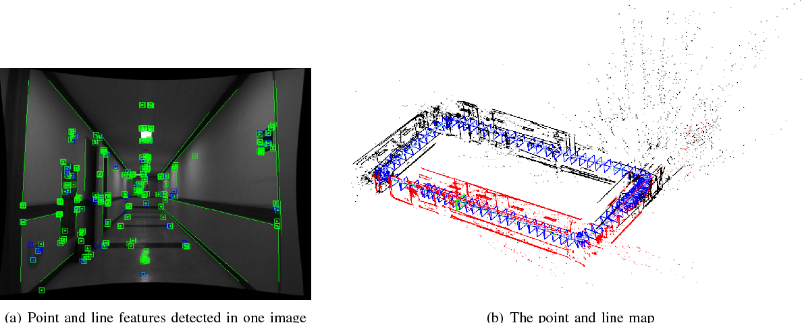

Figure Visual SLAM Example [20]

The green boxes presented in the above figure represent the features the robot extracts when it is trained on the environment, and then its uses those features later when working autonomously to locate itself. The right side of Fig. 6 holds the frames the robot captures when trained on the environment, and the robot when it maps itself in the environment, what it does is actually map itself to which frame it belongs.

##### Limitations:

Multiple limitations exist in this method, however, the most significant ones are related to the fact of relying on a camera. Indeed, image issues such as blurred images might provide misleading features to rely on. Also, this method is affected by the lighting conditions, where if the lighting conditions vary, different features might be recognized by the robot making it hard to localize itself properly. Lastly, and most importantly, in areas having almost same features such as an empty place with all the rooms being identical in terms of wall colors for example, the robot will not be able to properly extract features that differentiate rooms from each other, and hence, the robot will be confused when localizing itself.

##### Solution(s) to Limitation(s):

Image processing issues might be handled one by one, for example lighting conditions problems could be fixed by relying histogram equalization technique which fixes the color contrast of the frames, making all the intensities almost consistent with each other [21]. As for similar environments, some type of deep learning algorithms could be used to enhance feature extraction.

#### Lidar Based Navigation:

##### Concept:

The most common method is the LIDAR sensor based approach. In this method, the LIDAR sensor is used where it emits rays in 360 degrees directions. By measuring the time needed for the rays to bounce and reflect back, it can map the environment and know whether obstacles are nearby or not. This is the way the robot maps the environment simultaneously. In case the robot is already trained on the environment and just needs to localize itself, then it uses the data from the LIDAR sensor and compares it to the data the robot is trained on regarding the environment, compares the distances and coordinates to finally know its position. Fig. 7 below illustrates the working principle of the LIDAR sensor:

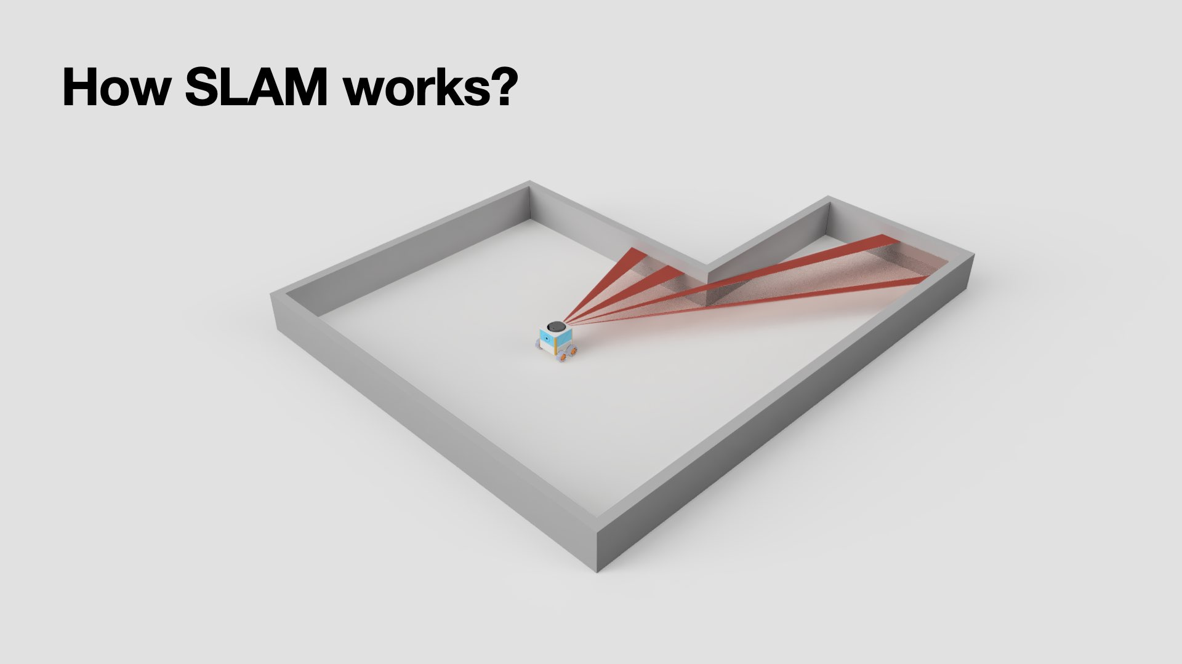

Figure Working principle of LIDAR sensor [22]

Usually gazebo environment along with rviz are used to monitor the robot’s movement, and realize the map the generated. An example can be shown in the figures below:

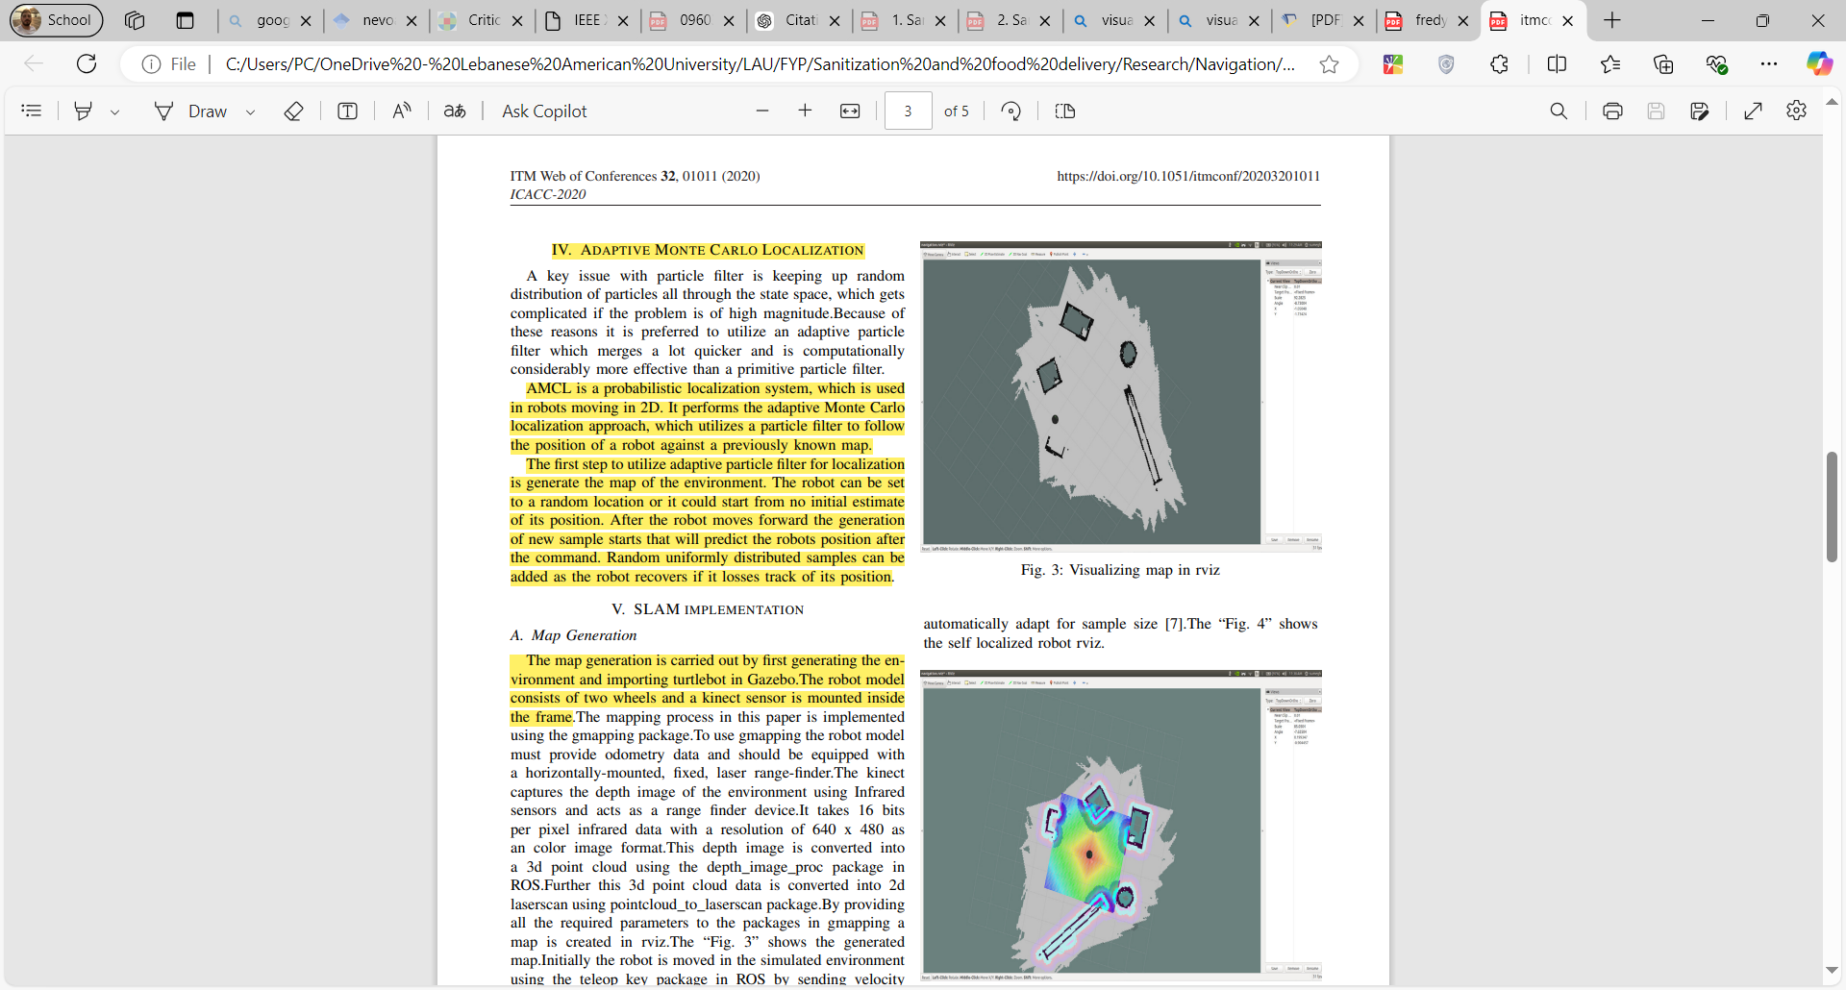

Figure Map of the environment using rviz [23]



Figure Location of the robot in the map using rviz [23]

##### Limitation(s):

LIDAR sensors suffer from not being able to detect transparent objects such as glass as laser beams emitted from the LIDAR can pass through them without bouncing back to the LIDAR. Another issue is the case of using some reflective materials that reflect laser beams indefinitely, without capturing them back by the LIDAR. With this the sensor does not detect any obstacle by the time there exists. Also, one of the most significant issues is struggling to localize accurately in open fields with small amount of landmarks. This is because LIDAR relies mainly localizing the robot through discovering the features of the surrounding environment, however, if no landmarks are present such as presence of a wall, a chair … the LIDAR will not know its position accurately.

##### Solution(s) to Limitation(s):

In featureless environments, where there are no enough landmarks, a GPS could be combined with the LIDAR to locate the robot accurately. Another solution to this issue could be combining the LIDAR with am IMU which will be tracking the location of the robot and providing better location data even when reaching featureless spots. Regarding objects that can reflect LIDAR’s laser beams indefinitely, or that laser beams can penetrate due to transparency, an additional camera for example could be used and that notes the presence of some object that was not detected by the LIDAR.

## 2.5. Comparison between options

Table table of comparison of each section

|  |  |  |  |
| --- | --- | --- | --- |
| Category | Method | Significance | Limitations |
| Sanitization | UV-C light | High efficiency (99.99% disinfection), eco-friendly, no chemicals | Should be operated in empty rooms, cannot cover shadowed areas, cannot penetrate dust |
| Wet Mopping | Cost-effective, reduces manual labor, simple to implement | Only suits floors and surfaces, are not optimal, involve misuse of wipes |
| Vacuum Cleaning | Removes debris, prepares surfaces for sanitization, reliable automation | Does not disinfect, it just removes dust/debris​ |
| Steam Cleaning | No chemicals required, effective for deep cleaning | Heavy equipment and need of high temperature operations |
| Spraying | Ensures thorough disinfectant coverage, reduces wastage | Can damage hospital material |
| Ozone Gas | Covers large areas, sterilizes both air and surfaces, leaves no residue | Toxic and not environmental friendly |
| Delivery | Tray Delivery | Easy to load and unload, cost-effective | Low security, unsuitable for sensitive materials |
| color-coded drawers | Organized categorization, simple to operate | Requires manual organization, moderate security |
| compartment-based delivery | High security, ideal for sensitive materials | Expensive, requires maintenance |
| pre-packed containers | Pre-organized, reduces handling effort | Limited flexibility for customized deliveries |
| self-serve dispenser | Convenient for frequently accessed items, minimizes human interaction | Limited storage capacity, requires frequent refilling |
| Navigation | wireless control | Easy remote operation, low-cost implementation | Does not allow autonomous navigation, and robot cannot move in case connection is lost |
| Odometry based SLAM | Robust performance in areas with poor features and cost effective in terms of sensors | Highly affected by drifts leading to errors and inaccurate localization |
| Visual SLAM | Relies on camera which is relatively low cost, and allows detection in texture similar to human vision making it most suitable for AR/VR applications | Highly affected by lighting conditions, blurred scenes, and might not work properly in areas having similar features |
| LiDAR based SLAM | Provides accurate localization in 2D/3D maps, independent of lighting conditions, and not affected by drifts | Struggles in open fields where no surrounding objects are present, and is not able to detect transparent objects |

# 3 Existing Solutions

## 3.1 ‘Xenia: The Medi-Assist Robot’ for Food Delivery and Sanitization in Hospitals [24]

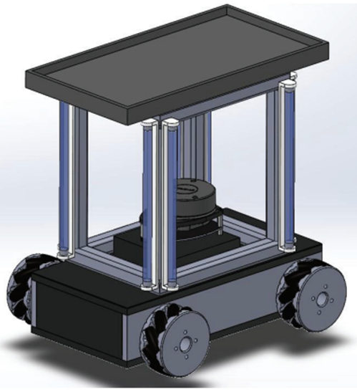

Figure 10 Isometric View of Medi-Assist Robot CAD model [24]

### Aim:

Delivery of food and medicine trays to the patients.

Sanitization of wards and rooms once they are vacated.

### Implementation:

#### Navigation:

* Robot communicates with a mobile device via Bluetooth to receive instructions regarding which bed to deliver the food tray to.
* The mobile device and the robot are controlled by trained hospital staff responsible for initiating and overlooking the food tray delivery process.
* For the robot to know the specific location of each bed, the robot coordinator needs to manually jog the robot to the desired bed location and use the mobile application to capture the coordinates. Then they will be used as a reference during the delivery. This process needs to be repeated for each ward/room. After this is carried out in all the rooms, the robot will know the locations of all the beds in individual rooms.

#### Delivery:

* The robot coordinator will place a food tray on top of the robot and choose the bed number to which the food tray is to be delivered. Upon receiving the command, the robot will make use of the probabilistic approach method to calculate the shortest and fastest path to the bed.
* Once it reaches the bed, the patient will pick up the tray. When the pressure sensor detects the tray has been lifted, it will wait for a specific amount of time and come back to the starting location.

#### Sanitization:

* 8 UVC Lamps are used. Two lamps are attached to each of the four columns of the upper body frame.
* The robot needs to know the four corner coordinates of the room, therefore, the robot coordinator will have to jog the robot manually to all four corners of the room.
* These coordinates will then be captured and used as a reference during the autonomous sanitization
* Once the sanitization process begins, the robot traverses through the four corners while avoiding obstacles using the LIDAR (Light Detection and Ranging) sensor, and by following the a zig-zag path as shown in the figure below:

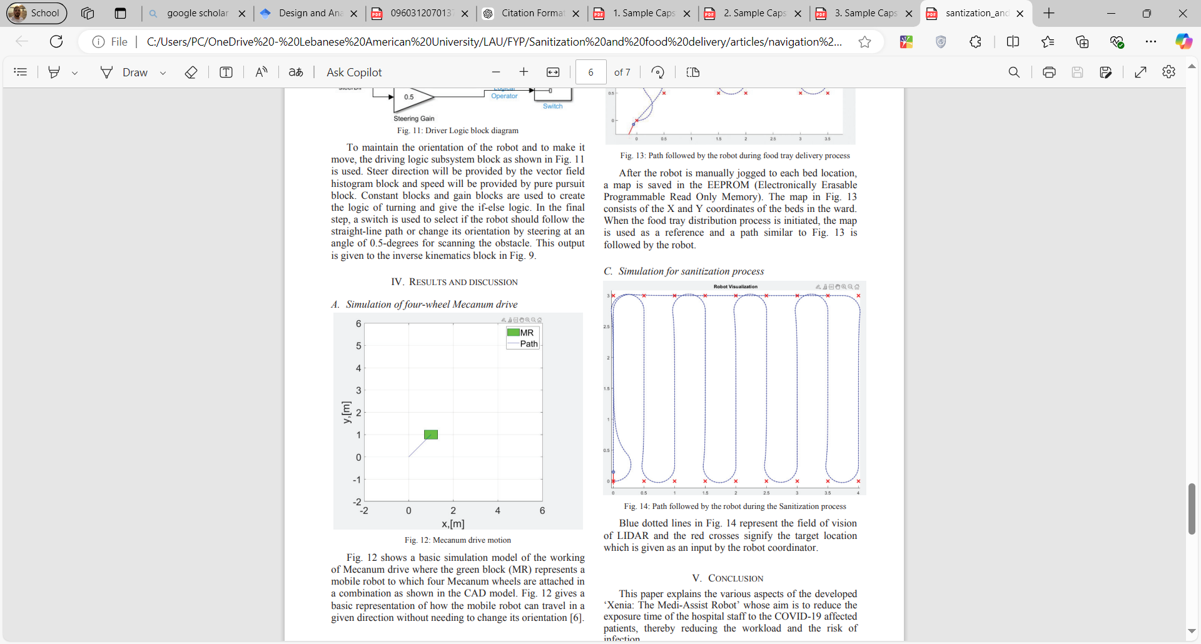

Figure 11 Path followed by robot during sanitization process [24]

## 3.2 Robot IRIS 3200 m [6]

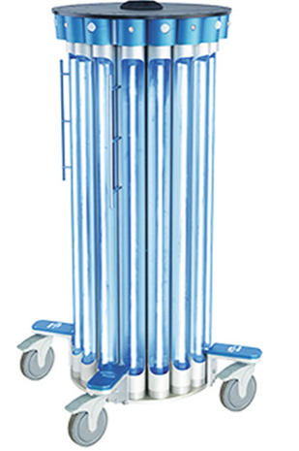

Figure 12 Robot IRIS 3200 m [6]

### Aim:

* The robot describe is an attempt to reduce the risk of hospital infections.

### Implementation:

#### Sanitization:

* Uses a smart disinfecting system that assesses the surrounding conditions, the area, and computes accordingly the dosage of UV-C to be used with the time needed to complete sanitization.

### Significance:

* This robot is the most powerful system for disinfecting using UV light. Its intensity and severity on pathogen disinfection was found to be stronger than tested xenon pulse system by 20 times, and up to 3 times other constant light emitting systems.
* Can automatically measure the size of the room, and its conditions in real time, then decide on the required dosage, number of emitting lights, and time needed for complete disinfection.
* Controlled by a wireless handheld Steri-Strip controller.

### Conditions:

* UVC light cannot go through safety glasses, walls or windows.
* Position of the robot in the room could damage eyes so always run the robot in an empty room.

## 3.3 Xenex UV-C System [6]:

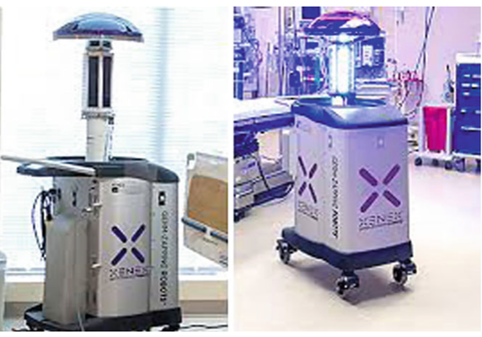

Figure Xenex germ-zapping robot with LED xenon bulb [6]

### Aim:

* Disinfecting surfaces with a low-cost and energy efficient method.

### Implementation:

#### Sanitization:

* Navigates through areas sanitizing them using Xenon pulsed bulbs, and are acquired with motion sensors that detect any human motion. This robot does not navigate, but rather is manually positioned in the area it should be operating in. For example, it is turned on (but not emitting UVC light), and pushed by the staff to the proper position. Once it is positioned correctly, the staff go out of the room and the robot turns on UVC light to do disinfection. If there was motion, the sanitizing system shuts down to avoid endangering humans.

### Significance:

* High intensity UV light is produced by xenon flash lamps and that target the DNA and proteins in the DNA of the cells damaging them.
* Kills germs without the use of chemicals.
* Has a motion sensor that shuts down the UVC disinfection in case of movement nearby.
* Energy efficient as it does not generate continuous lighting.

### Conditions:

* Can do proper disinfection on dry areas. Areas having fluid or dust on them cause a barrier in front of UVC rays to do sanitization.
* UVC rays can be blocked easily even by a simple plastic bag.

## 3.4 SANITIZER SPRAYING WIRELESS ROBOT FOR QUARANTINE CENTERS & HOSPITALS [15]

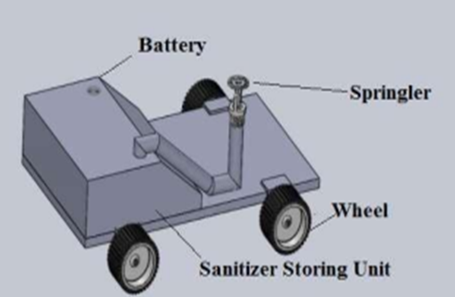

Figure 14 Wireless-controlled spraying robot model [15]

### Aim:

* The system is capable of sanitizing the floors of hospitals. The application area can include hospital corridors, medical shops, operation theatre, walking pathways, doctor room, testing center, and patient room, etc.

### Implementation:

#### Navigation:

* This system has three types of path tracker, obstacle detection system, and remotely operated system. HC-05 is a Bluetooth module that establishes a wireless network. The robot can be controlled remotely using this Bluetooth module, and with a UI presented in Fig. 4.

#### Sanitization:

* The portable sanitizer unit is attached to the top of the mobile robot. The system integrates a sprinkler mechanism and is used to distribute air and disinfectant fluid mixture.
* The robot cans automatically patrol for sterilization and disinfection in a predetermined area. The sprinkler is equipped with a double-acting pneumatic cylinder, and the purpose of the cylinder is to push the air into the tank.

### Significance:

The system is capable of disinfecting an area of up to 100 m2 per day.

### Working Principle:

* The main components consist of a sprinkler robot, DC motor, Bluetooth module, Arduino, Motor driver, Submergible pump, Sprinkler, Battery, DC Converters.
* Lp2148 microcontroller is used to control the system. The aim control is to assess the surrounding atmosphere, and based on the data, appropriate commands are given to the sprinkler.

## 3.5 TUG Autonomous Robots

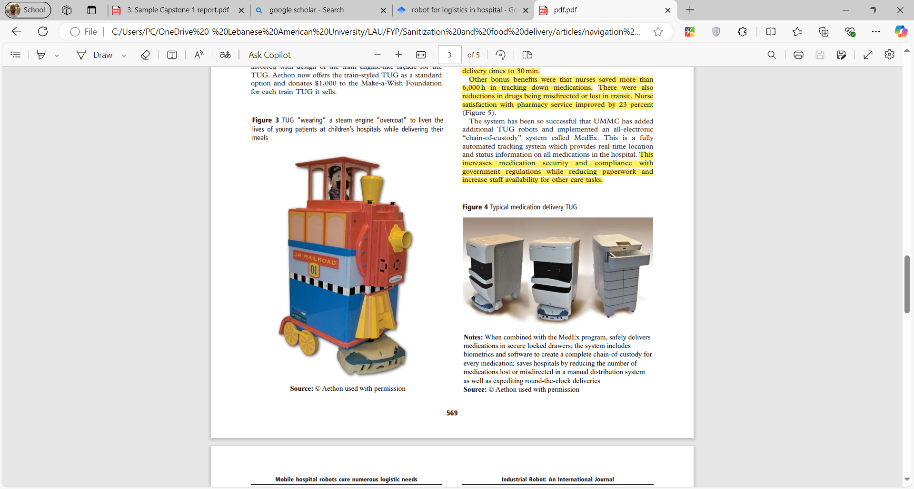

Figure TUG robots [25]

### Aim:

The development of this robot aims to facilitate logistics operations in hospitals from food delivery, to pharmaceutical uses such as drug delivery, as well as carrying clean linen to the rooms.

### Implementation:

#### Navigation:

* The robot can do the navigation through feeding it with a CAD model of the environment, or by manually moving the robot through the environment to build its map.

#### Delivery:

* The robot operates by doing delivery tasks. When it arrives to the destination, it announces through the speaker that it has arrived. The staff does the unloading of the delivered stuff. When the unloading is done, the staff instructs the robot whether to go to the main point or to continue its delivery tasks.

### Significance:

**University of Maryland Medical Center:**

Reducing average delivery time from 74 min to 30 min.

Nurses saved more than 6000 h in medication delivery tracking.

Nurse satisfaction with pharmacy service improved by 23 %.

**El Camino Hospital Silicon Valley:**

Automating over 80 % of delivery tasks from food, linens, and pharmaceutical supplies.

Saving more than 650,000 $ a year in wages and benefits [25].

### Working Principle:

The robot consists of:

A control module with wifi capabilities as to allow several TGU robots communicate using TGUOS. Also, this module is used for the robot to communicate with the elevators of the hospitals in case they are to be used. The elevators the robot use are those designed for staff only, and are separate from those of public in order to facilitate their work.

Various sensors are used to detect people and obstacles. Sensors include sonar, laser, and infrared sensors. A speaker is deployed on the robot to communicate with people, such as asking people to move aside if they are blocking the way of the robot, or to ask people to receive the food when it is delivered successfully for example.

# 4. Proposed Implementations

|  |  |  |  |
| --- | --- | --- | --- |
| Design | 1 | 2 | 3 |
| Sanitization / cleaning methods | Vacuum Cleaning | UV-C light | UV-C light |
| Spraying | Steam Cleaning | Vacuum cleaning |
| Ozone gas | - | Wet mopping |
| UV-C enhancement | - | Hydrogen peroxide vapor | Reflective component on the robot |
| Delivery system | Packaged Containers | Drawers | Tray delivery |
| Navigation | Visual SLAM | Odometry-based SLAM | LiDAR-based SLAM |

Figure Proposed implementations

## 4.1. Approach 1

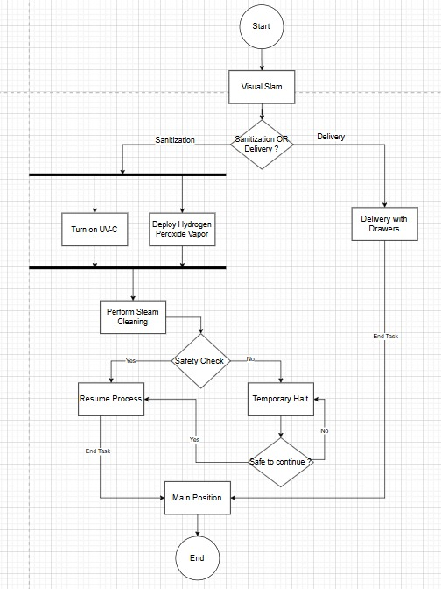

Figure Activity Diagram of Design 1

## 4.2. Approach 2

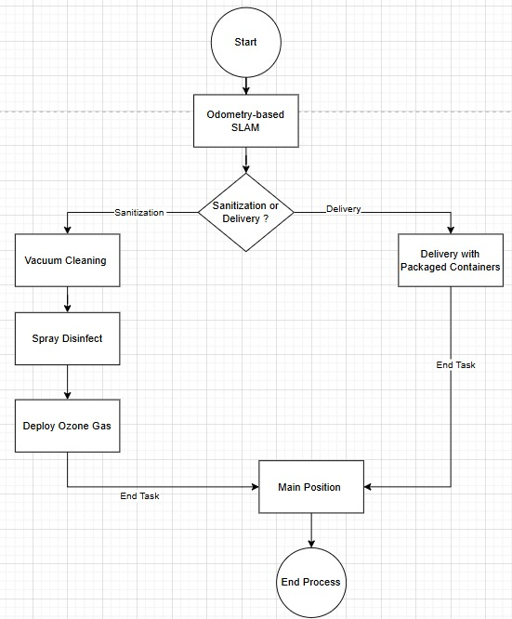

Figure Activity Diagram of Design 2

## 4.3. Approach 3

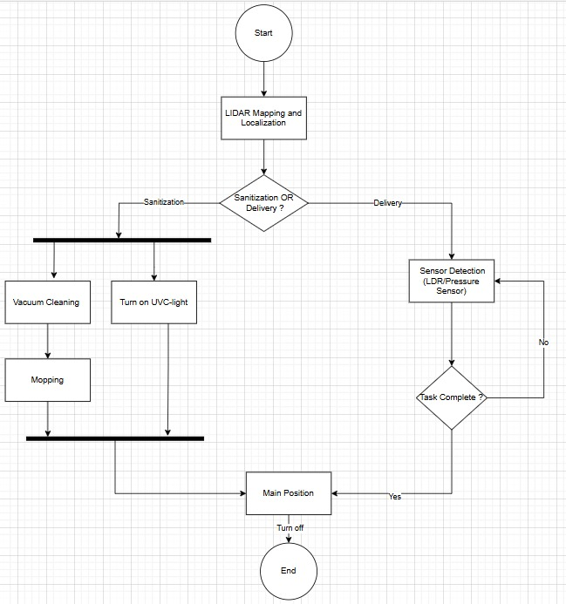

Figure Activity Diagram of Design 3

## 4.4. Analysis

Of the suggested designs, Design 3 is the best fit for our hospital-focused sanitization and delivery robot for these reasons:

### Protection for Individuals and Medical Instruments:

Design 3 employs UV-C lights for disinfecting surfaces, making them very effective and environmentally friendly. For safety reasons, UV-C lights are set to turn off upon detecting humans, safeguarding both staff and patients. The vacuuming and wet mopping systems ensure comprehensive cleaning while protecting delicate medical devices, in contrast to steam cleaning which requires heavy and expensive equipment along with high temperature sources, or ozone gas which is hazardous and not environmental friendly, or even spraying that have proven to damage hospital material.

### Delivery Structure:

We choose to go for a simple and straightforward delivery system composed of a tray. All the other options such as drawers or packaged containers can also be done.

### Navigation:

Design 3 proficiently merges automated cleaning and delivery with accurate navigation (LIDAR SLAM). This guarantees that the robot can function independently and dependably in different hospital configurations. For instance, odometry-based SLAM leads to drifts and errors as the robot relies on it for navigation, not only this but it also accumulates them leading to inaccurate localization and mapping of the robot which might cause the robot to enter the wrong room, thus it can be eliminated. Visual SLAM relies on the lighting conditions and features captured by camera, and since corridors and rooms in hospitals are most of the time having the same form where little difference could be noted in the design of each, Visual SLAM would not be the best solution to be used as with it the robot might by mistake localize itself in the wrong place. This leaves us with LiDAR based navigation which has proven to be robust and accurate in 2D and 3D maps, and is a solution not correlated with drifts.

### UV-C enhancement:

Design 3 improves UV-C disinfection by incorporating reflective elements on the robot, allowing for efficient redirection of UV-C light and minimizing the requirement for extra UV-C units.

The hydrogen peroxide vapor enhancement in Design 2 necessitates continual chemical replenishment, leading to rising costs with time as well as more sophisticated systems.

Design 3 is inexpensive and flexible, lacking substantial maintenance or operational expenses. It improves the efficiency of UV-C light without needing any structural modifications or chemical refills, in contrast to Design 2.

In Conclusion, although the expense of the hardware in design 3 is quite significant, it eliminates the extra complications and safety issues linked to ozone gas or steam cleaning. It harmonizes practicality and security, rendering it the best option.

# 5. Detailed Preferred Implementation:

Our implementation is mainly based on using the turtlebot, namely turtlebot3 in our case, to carry the project. On the turtlebot we decide to build several layers, each layer specific to carry some load of electronic circuitry, or to be used for handling the hospital logistics of sanitizing or cleaning. For instance, we consider in our case to have layers that hold batteries, electronic sensors or motors used, electronic boards or PCBs or microcontrollers/microprocessors used, carrying sanitizing components, as well as carrying the LIDAR sensor responsible for localization and mapping. The system can be presented as follows:

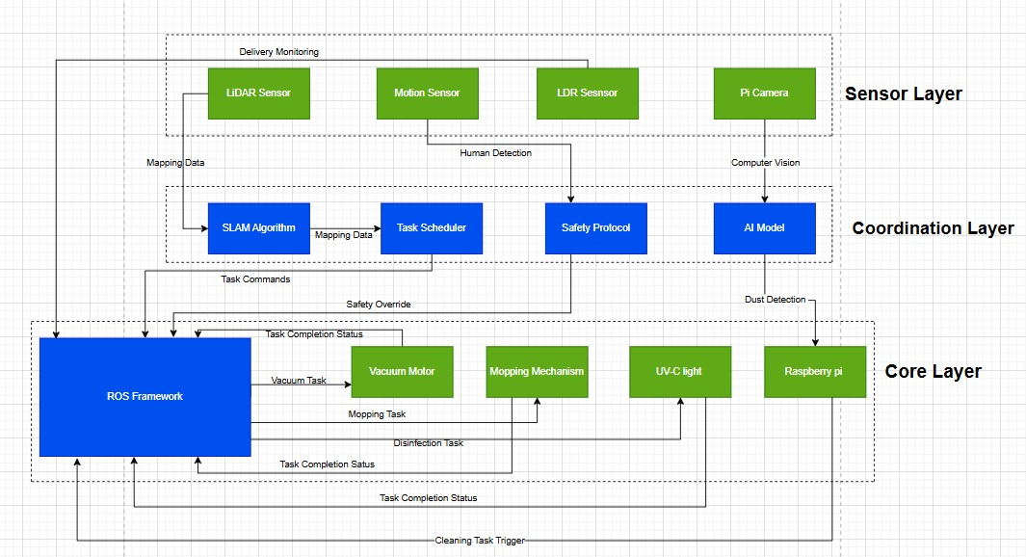

Figure System's architecture

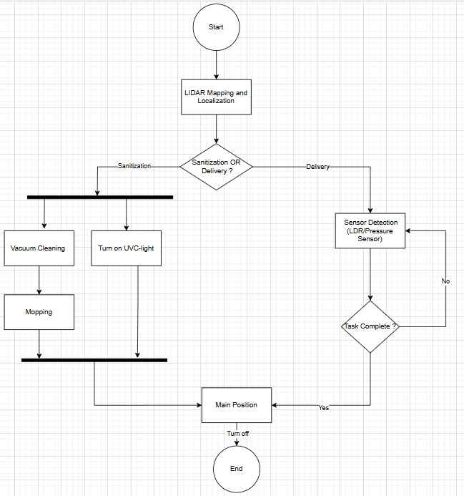

Figure System's activity diagram

As a matter of dissecting each hardware part, the reason behind using it, as well as the way it is used, and regarding the software implementation we elaborate the system as follows:

## Sanitization

### UV-C disinfection

#### Reason of using it

The use of UV-C rays as a disinfecting technique seems to be a must in the modern days. This decision falls behind the fact that the traditional cleaning and sanitizing techniques are not optimal, as well as having housekeepers in hospitals wipe only 40 – 50 % of the surfaces that need to be cleaned [1]. Another reason is the fact that spraying, which is also considered to be one of the most effective sanitizing techniques, leave residues when used and can cause corrosion to hospital material, especially metals [2].

On the other hand, UV-C sanitization does not involve any type of liquid material, but rather it is the use of rays having frequencies between 200 nm and 280 nm. Those rays have proven to be able to damage the DNA of microbes and pathogens, and thus not allowing them to recover or reproduce [7]. Therefore, we can conclude that this method is not affected by the virus’s or bacteria’s size, its whole work is focused on damaging the DNA of those cells [10]. Aside from that, this method has also proven to be the strongest in terms of sanitization as it can eliminate up to 99.99 % of microbes without generating harmful chemical residues [5].

#### Types of UV-C sanitization

As the use of UV-C disinfection in hospitals is mandatory nowadays, it is important to address the different types of this sanitization technique:

Table Comparison of different types of UV-C light sources [3]

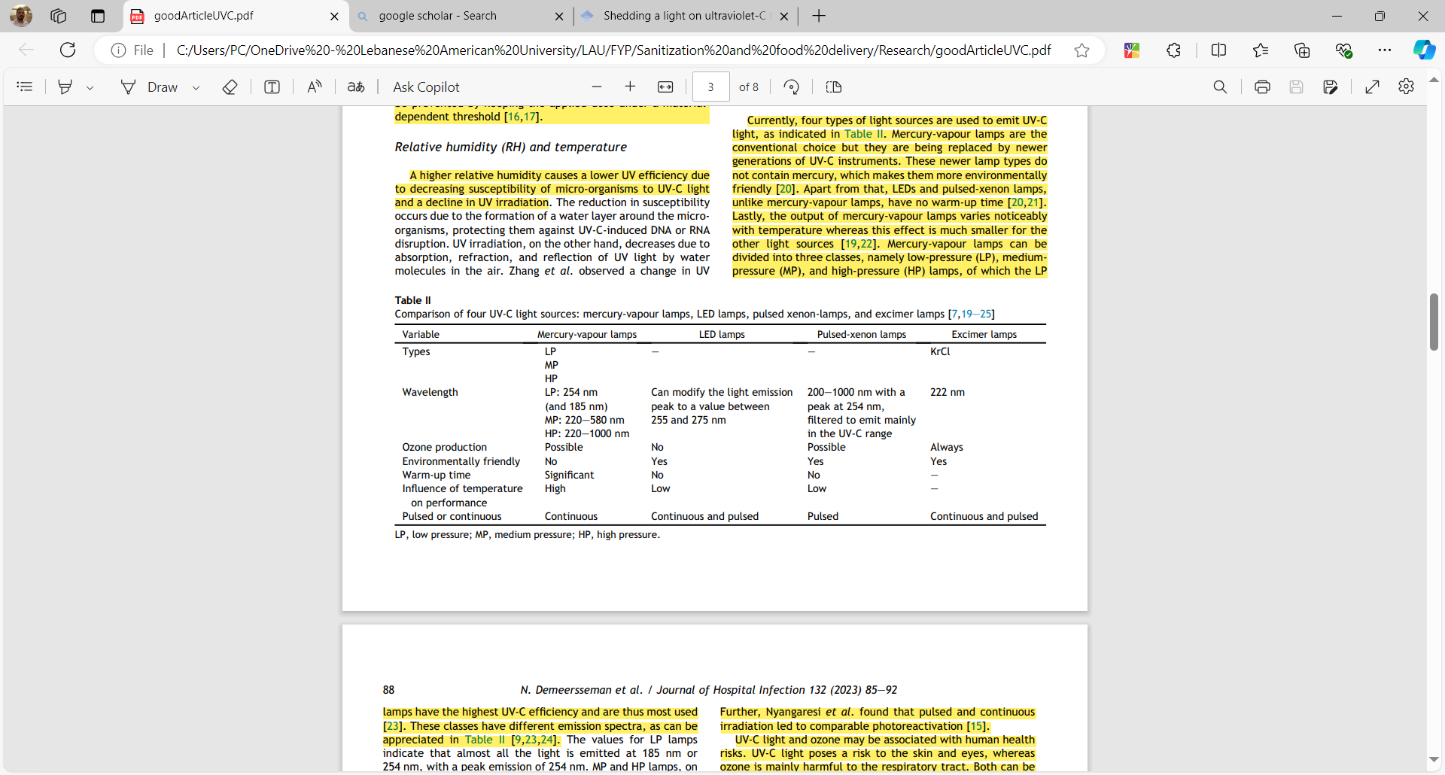

According to Table 2 which compares four different light sources of UV-C disinfection method, it can be seen that the LED lamps are the best to be used in terms of ozone gas emissions as they do not emit those gases, being environmental friendly, not requiring a long warm-up time, and low influence of temperature on their performance [3]. Additional to this, [3] also state that this type of lighting can be offered in both continuous and pulsed adding more flexibility to the system. This therefore justify the reason behind using them in our design.

In fact, even though this type of lighting does offer both continuous and pulsed lighting, yet it is essential to specify which type is to be used in our design. In our case we decide on the use of continuous lighting with the LED lamps. Even though it was found that pulsed light has a higher penetration depth and can produce higher light energy, increasing intensity [26], and [27] has compared pulsed and continuous light emitted by LEDs showing that the results of both are comparable to log10 reductions (in the order of 90 %), however there is a tradeoff between saving energy, and using more complex system. Continuous lighting is easy to be done, however, implementing a pulsed system is more complex since it requires building a circuit that provides the lamp with a square signal that requires more hardware.

As a result of this, we resort into using LED lamps for UV-C emissions in the continuous mode just for simplifying the system, however, for saving energy, being environment friendly and not emitting toxic materials such as ozone, and doing the sanitization task with highly effective outcomes in the order of log10 pathogen reduction, using pulsed lighting should be a future work improvement.

#### Method for enhancement

UV-C disinfection has several limitations presented by Table 3:

Table Limitations of UV-C disinfection and their solutions [3]

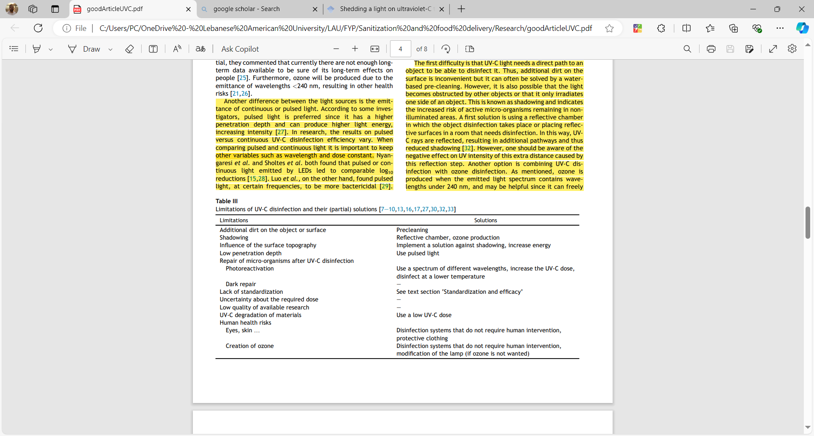

So looking onto those limitations, low penetration depth is solved by deciding on the use of pulsed LED lamps, which is to be solved by future work. As a matter of solving shadowing issues which is a major problem in our case since with its presence, UV-C light will not able to cover and sanitize those shadowed areas, we introduce the use of UV-C reflective materials into our system. Those materials will reflect the UV-C light hitting them expanding the coverage area of the disinfection, as well as to increasing the order of disinfection itself. To elaborate, the raw UV-C light has proven to disinfect by almost 99 % the environment. And when the UV-C rays are reflected, this disinfection capability is still present but in less intensity by which it could reach 10 – 20 % depending on the distance from the light source [10] [4]. Therefore, this proposition is a solution to allow disinfection for shadowed areas, and provides more sanitization within a given time.

Investigations have been made regarding the reflective materials that could be used. [28] has compared the reflectiveness of 21 different materials known to be highly reflective, and varying between metals and non-metals. Those materials were subjected to three different UV-C frequencies. Results have shown that Aluminum foil tape is the most reflective material amongst all, with a reflection exceeding 60 %. Another study taken into consideration has also done experiments to find the most reflective material to UV-C light, comparing 4 reflective surface materials. It was found that Microporous PTFE is the most reflective one, and Aluminum foil being the second most reflective material [29]. Therefore, Microporous PTFE is the most reflective material, which is to be considered in the implementation of our project.

Regarding the other limitations present in Table 3 such as the presence of additional dirt on surfaces, human health risks, and standardization to UVC, they are to be presented in later sections of the report.

#### UVC disinfection evaluation

As a matter of comparing both methods:

Table Comparing methods of UVC disinfection assessment

|  |  |  |
| --- | --- | --- |
| Aspect | Method 2 (with assumption) | Method 1 (without assumption) |
| Focus | Microbial inactivation based on experimental data | Spatial distribution of UV-C intensity in a 3D environment |
| Complexity | Simpler, requires experimentally determined k and D | More complex, requires detailed geometry and light modeling |
| Input parameters | Microbial constant k and total dose D. | Source power P, geometry of the room, and source placement |
| Output | Fraction of microorganisms inactivated | Intensity at any given point, which can then be used to calculate dose |
| Assumptions | Uniform dose distribution across all surfaces | Varies intensity based on distance and angle from the source |
| Use Case | Quick assessment of disinfection effectiveness | Precise dose calculation for unevenly distributed UV exposure |

#### Limitations and conditions of use

The use of UVC in our system has several conditions that we consider, primarily using them in rooms where there are no humans. It was proven that UVC light damages the human skin and eyes when subjecting them to people, therefore the use of UVC disinfection in our case is to be done in empty rooms [7] [2] [3].

Another constraint is that some materials get damaged when subjected to UVC rays in a dose exceeding the threshold they can sustain. Thus, when calculating the time needed to do disinfection using UVC, we should consider an intensity that results with a dose less than the maximum sustained by the material [3].

### Vacuum Cleaning

One of the limitations addressed in the UVC disinfection method in Table 3 is the presence of dirt on surfaces not allowing to sanitize the area under this dirt. The solution to this is preclearing as mentioned. Thus, vacuum cleaning could be used as one of those methods to handle the preclearing of surfaces removing dirt, debris, or dust from floor or crowded areas.

In this project we develop our own vacuum cleaner following the same steps described in [30]. The idea behind the development is using a bottle as a container, creating holes at the bottom of the bottle that push air outside, inserting a DC motor inside the bottle to enforce the aerodynamics to create a pressure difference between outside and inside, and using a filter that carries the sucked debris. A CAD model was done as an illustration as is shown in Figure 16:

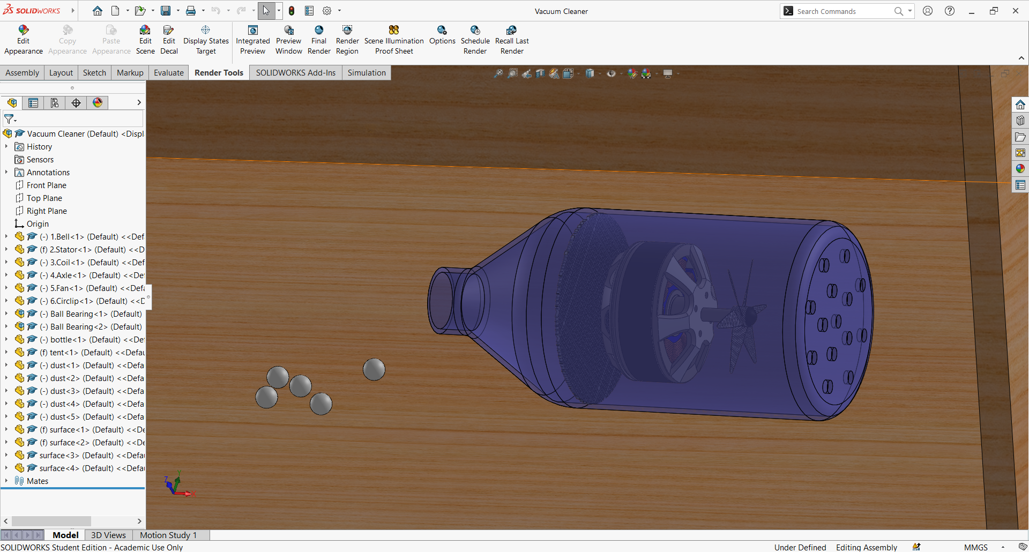

Figure CAD model of the designed vacuum cleaner

As mentioned earlier, the DC motor rotates, and due to the opening of the wholes at the bottom of the bottle and the top of the bottle there is a pressure difference between outside and inside of the bottle. This cause the dirt to be sucked by the vacuum cleaner and get stuck inside by the presence of the filter.

The vacuum cleaner in our system is controlled by an AI model, namely a deep learning model that uses computer vision to see if there is dust/debris or not. If there is dust/debris, the vacuum cleaner is on to remove them, else the vacuum cleaner is off.

### Mopping

The intended system to be created for mopping is such that there is a sprinkler that pours some disinfecting solution onto the floor, such as hydrogen peroxide [4], and a brush or sponge is used to wipe them. We do not intend to do any sophisticated task in this, but rather only to have a clean floor for the room.

The robot in our case is to navigate through the room twice. The first navigation is for the work of both the vacuum cleaning and UV-C disinfection. And the second time is for mopping and the continue of UV-C disinfection.

## 5.2 Tray Delivery

The robot we aim to build is based on the turtlebot3 as mentioned, and thus we build up several layers. Some of the layers are to be used for the delivery task handled by the robot. The delivery is based on having trays on those layers of the robot, where each tray carries the stuff that are to be delivered to the specified room. This tray delivery system could be thought of similar to the one built in [24] or drawers carrying stuff as in [25].

The robot designed is to handle both food delivery tasks, as well as delivery of drugs that require no special conditions to be carried.

A sensor is placed on the tray to know whether the food/drug delivered were taken by the recipients or not. To elaborate, the design we create is that hospital staff place the object to be delivered on the tray, and instructs the robot to go to the room, which is the destination of the delivery. Once the object on the tray is taken by the nurse or patient in the room, a sensor placed just on the bottom of the object senses change in its signal, therefore the robot knows the object was already taken and now it can continue its work or go back to its origin where hospital staff are present.

## Robotic Navigation

### Navigation

There exists plenty of methods that handle the navigation of the robot, and multiple methods are already discussed in the background section including remote control and autonomous navigation. Since the robot we intend to design is an autonomous robot, therefore, it is essential to rely on localization and mapping techniques.

Here it is important to split between 2 different core concepts, ‘SLAM’ and ‘localization and mapping’. The key difference between both is that SLAM is a simultaneous action of the robot that tries to build and structure the map of the environment while navigating an area. On the other hand, localization and mapping does not involve simultaneous mapping, but rather the robot is already trained on the map, and the robot uses the sensors just to coordinate itself within this map it is trained on.

In our application, since the robot is to be used in a specific hospital, we resort into training the robot on the map of the environment, that is we design the environment and feed it to the robot. The robot will hence have all the information about the structure and the map it will be navigating on. And now, all what we have to do is tell the robot where it is present at as an origin, and instruct it to go to a certain place, which is in our case the room to be sanitized or the destination of the delivery. The robot moves in the hospital, and as it is moving it uses the data read by the LIDAR sensor in real time to locate itself in the map and know how to reach finally the destination.

### Path Planning

In order for the robot to go from one place to another, and since it was fed with the map of the environment that is it now knows the structure of the environment, the robot creates landmarks in this map. Thus, several algorithms could be done over those landmarks for the robot to go from one place to another such as the dijkstra algorithm, or A* algorithm, and others. Those algorithms are usually used by the robot to do its motion planning as it goes from a source to a destination.

Since in our project we do not intend to optimize the motion planning of the robot, but we want the robot to succeed in going from one place to another, we will not be experimenting different motion planning algorithms to see which one is the best.

## Control

Since the used prototype in our project is the turtlebot, which supports the use of ROS2, then control can be handled from ROS. To illustrate, ROS allows controlling the dynamics of the robot such as angular velocity, angular acceleration, linear acceleration along with other dynamic variables, and therefore in case any type of control is to be used, it can be handled through ROS. All that have to be done is modeling the system and writing the needed script to do this. Or even, another approach of the control which is independent of the modeling of the system could be using a PID control, through writing a C++ script in ROS environment to handle the control.

In our case we might need to do control for the turtlebot itself as it moves when doing the rotation in order not to deviate from its trajectory, or not to collide with the boundaries. This means that the control will be over the DC motors of the turtlebot holding the 2 wheels.

## Hardware Plan

The system’s CAD model was designed on SOLIDWORKS from complete scratch. The CAD model shows the structure of the system, the way each part is placed, and the accurate dimensions of the model. The CAD model is presented below as follows:

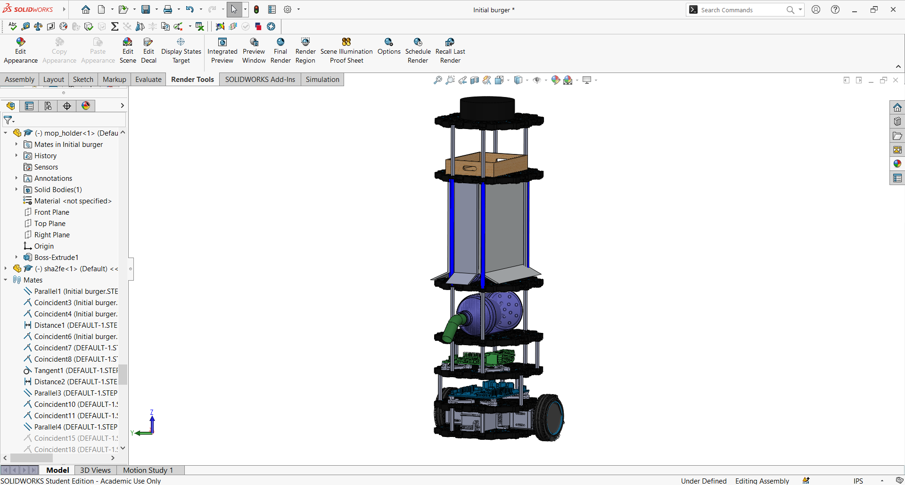

Figure CAD model of the system on SOLIDWORKS

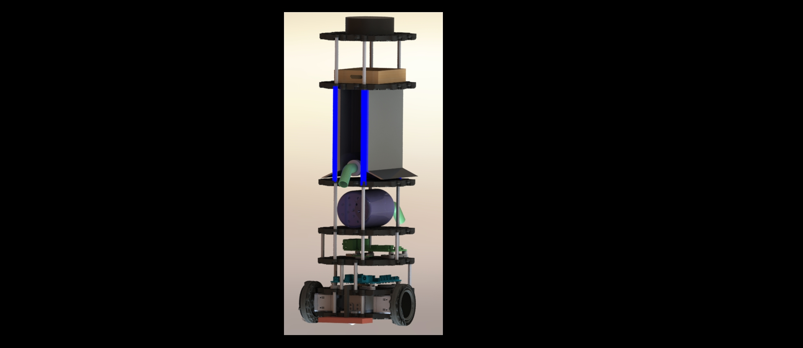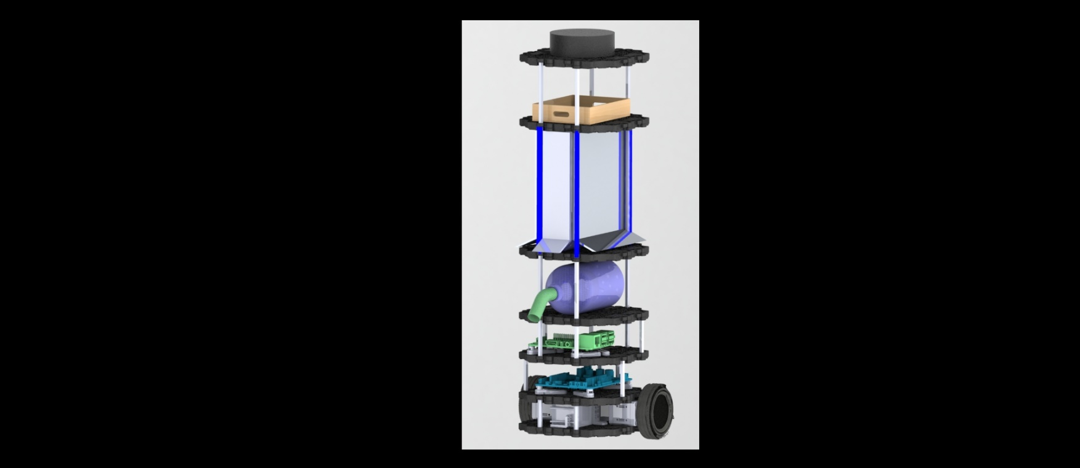

Figure SOLIDWORKS rendered images of the CAD model from different perspectives

As a matter of providing brief explanation of the CAD model, the whole chassis and rover is the turtlebot3 burger model used. It can be seen that several layers were made. The first layer from the bottom contains the DC motors of the wheels, LiPo battery powering the turtlebot, and external batteries that we intend to add. The 2nd and 3rd layers contain all the raspberry pi, and all other types of circuitry from PCBs to breadboards… The 4th layer holds the vacuum cleaner. The 5th layer holds the pump and the reservoir needed to sprinkle the solution for mopping mechanism. The UVC lights are seen here to be attached around the rods surrounding this layer. Also, a material is covering the pump and reservoir and is made of aluminum foil. The 6th layer holds the tray, and the final layer holds the LIDAR sensor.

**Adjusted Cad Model:**

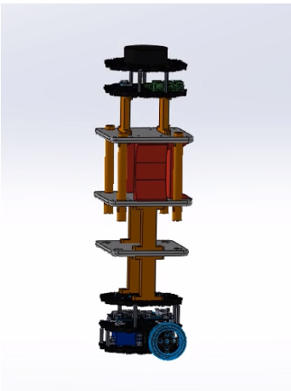

Figure New Cad Model

#### **Initial CAD Model**

As shown in **Figure X**, the initial design featured:

* A **multi-tier frame** with six functional layers, each housing a specific subsystem.
* **UV-C lighting tubes** on the vertical sides, aimed at maximizing exposure area for surface disinfection.
* A **mounted vacuum unit** with a side outlet and piping to guide airflow and dust collection.
* Dedicated space for a **delivery tray**, located near the top for food or medicine transport.
* Efficient integration of electronic control units and power supply modules.

While the model provided a modular and functional arrangement, it presented several challenges during physical prototyping, including:

* Excessive height, causing **balance and stability issues** during motion.
* Difficulty in sourcing and supporting the **curved transparent shielding** and complex structural parts.
* Alignment issues with motor and sensor placement in the lower layers.

#### **Final Adjusted CAD Model**

In response to these issues, a revised model was developed and is presented in **Figure Y**. Key changes include:

* **Reduction in height** and the number of tiers to lower the center of gravity and improve balance.
* Use of **simplified vertical supports** (orange structural columns) that are easier to manufacture and assemble.
* Centralized placement of electronics for better cable routing and hardware accessibility.
* Improved **layer spacing** to accommodate tubing, wiring, and actuation components without interference.
* A more compact and robust structure that maintains all essential functionalities while offering improved durability and motion stability.

This new design was successfully 3D printed and assembled, aligning well with the physical and operational constraints identified during the development phase.

#### **Conclusion**

The transition from the initial to the adjusted CAD model demonstrates the importance of iterative design in robotics. Balancing mechanical complexity with physical feasibility allowed the final system to maintain high functionality while ensuring reliable operation in real-world conditions. The final mechanical design not only supports all functional modules but also enhances system performance by improving weight distribution, stability, and accessibility.

The electronic circuitry of the system is described as follows:

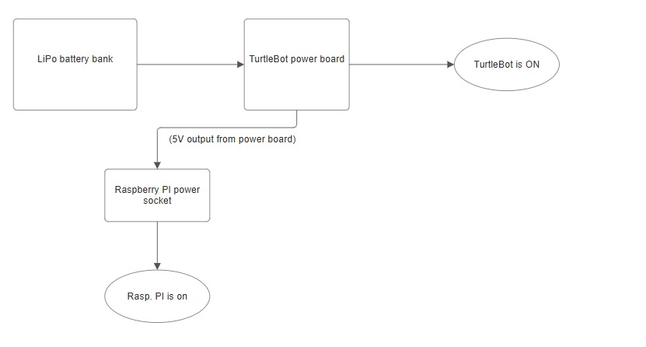

Figure Turtlebot and raspberry pi powering circuits

LiPo battery bank, which serves as the primary power source due to its high energy density and suitability for mobile applications, power is directed to the TurtleBot's power board. This board manages voltage regulation and distribution, ensuring that all system components receive the correct voltage levels. From there, the power board not only powers up the TurtleBot (indicating that it is operational), but it also provides a regulated 5V output specifically for the Raspberry Pi. This setup ensures that the Raspberry Pi is safely powered to handle computational tasks, sensor integration, and command execution, critical for the TurtleBot’s autonomous functioning.

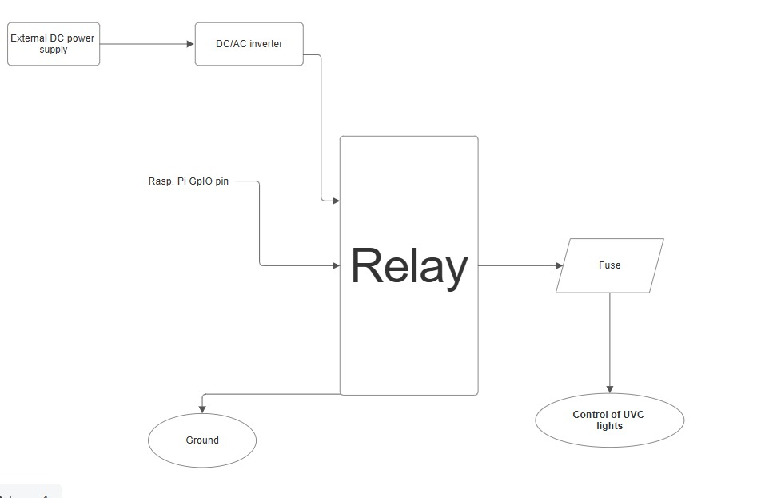

Figure UVC lights circuits

The setup starts with an external DC power supply connected to a DC/AC inverter, converting DC power into AC suitable for the UVC lights. This AC output is routed through a relay, which functions as an electronic switch controlled by a GPIO pin on the Raspberry Pi. Based on the control signal from the Raspberry Pi, the relay either permits or blocks AC power to the UVC lights. A fuse is positioned in the circuit immediately following the relay to provide overcurrent protection, ensuring the safety of the UVC lights and the overall circuit against electrical faults.

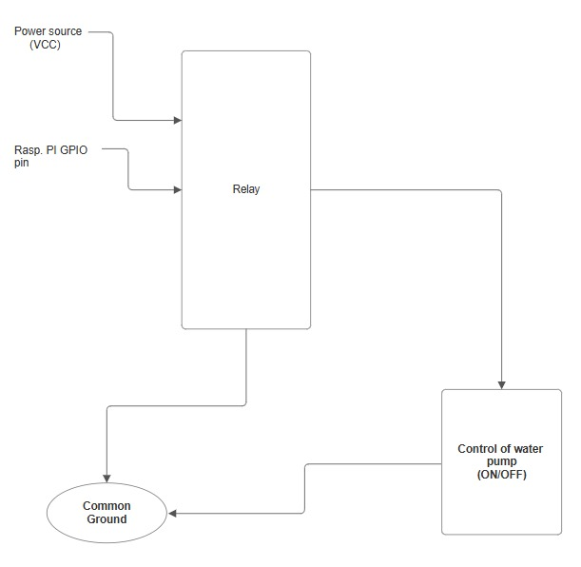

Figure Mopping pump circuit

The diagram illustrates a basic control system where a Raspberry Pi uses a GPIO pin to activate a relay, which in turn controls a water pump. The power for both the relay and the pump is supplied from a common VCC source, ensuring that the pump operates only when the relay is closed. This closure is controlled by the Raspberry Pi, which sends a high signal to the relay via a GPIO pin, triggering the relay to close and allow power from VCC to activate the pump. When the Raspberry Pi GPIO is set low, the relay opens, cutting off the power supply to the pump and ceasing its operation.

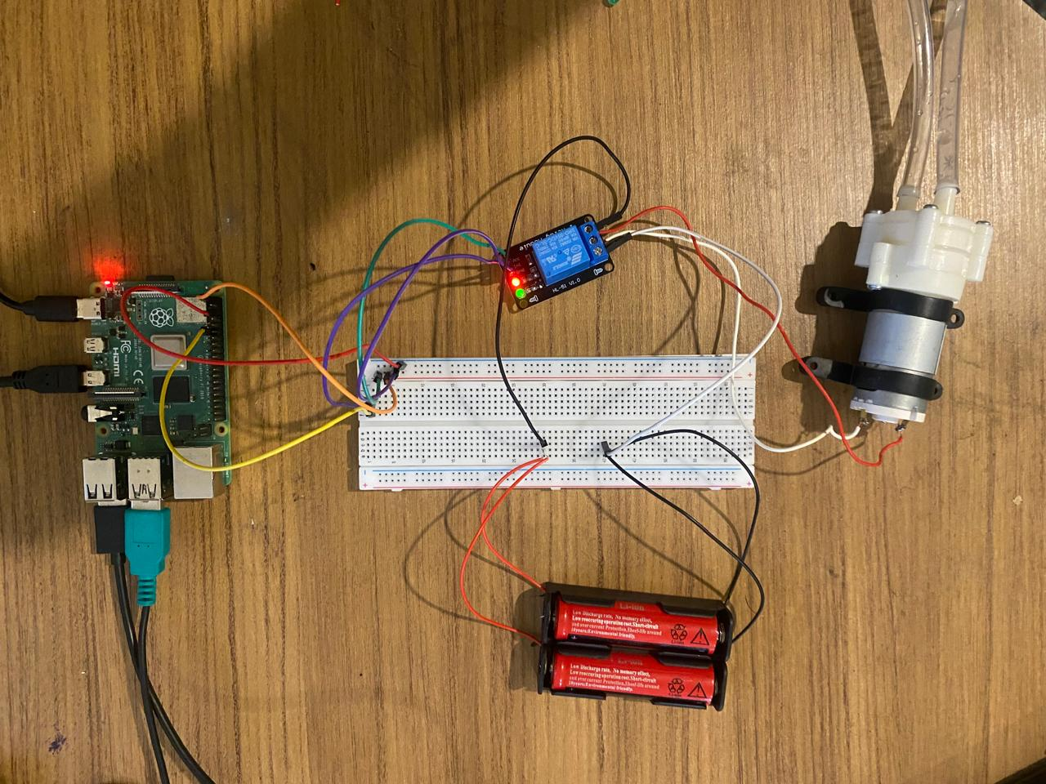

Figure Pump real circuit

The Raspberry Pi controls the water pump by sending digital signals to the relay module via one of its GPIO (General Purpose Input/Output) pins. When the AI model classifies a surface as "dusty", the Raspberry Pi sets the GPIO pin to **HIGH**, triggering the relay to **close the circuit** and allow current to flow from the external battery pack to the water pump.

As shown in figure above, the physical implementation of the system follows the structure of the logical circuit diagram. The connections are described below:

* The **relay module** is connected to:
  + **VCC** from the battery pack (to power the pump)
  + **IN pin** to a GPIO pin from the Raspberry Pi (to receive control signals)
  + **GND** connected to both the Raspberry Pi and the battery's ground, establishing a **common ground**
* The **pump’s power line** passes through the **normally open (NO)** relay terminal. When the relay is activated (GPIO HIGH), the NO terminal closes and completes the circuit, powering the pump.
* A **12V battery pack** is used as an external power supply to provide sufficient voltage and current to the motorized pump, without drawing power from the Raspberry Pi.

This setup ensures **safe electrical isolation** between the Raspberry Pi’s low-voltage GPIO pins and the higher voltage required by the pump, preventing potential damage to the Raspberry Pi.

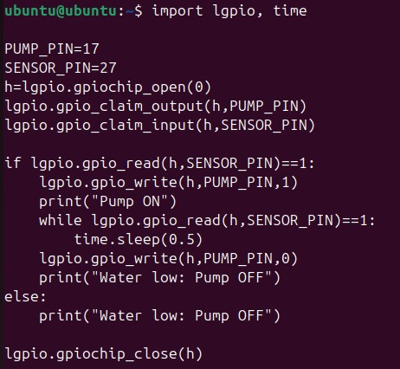

Figure Pump Control mechanism

To enhance the robot’s sanitization functionality, an automatic water pump control system was implemented. This subsystem ensures that water is dispensed only when there is an adequate water level, preventing dry operation and protecting the pump from potential damage.

#### **System Components**

* **Raspberry Pi GPIO pins** for control and sensor reading
* **Water level sensor** connected to a digital GPIO input
* **Water pump** controlled via a GPIO output and powered through a relay
* **lgpio library** for precise GPIO control using libgpiod

• The pump is connected to **GPIO17** and is turned ON or OFF depending on the sensor reading.

• The water level sensor is connected to **GPIO27**, which is configured as an input to detect whether water is present.

#### **Execution Flow**

1. The program checks if the **sensor pin reads HIGH (1)**, which indicates **sufficient water** in the tank.
2. If water is detected:
   * The pump is activated by writing a **HIGH signal to GPIO17**.
   * The system continuously checks the sensor reading every 0.5 seconds.
   * As soon as the water level drops (sensor goes LOW), the pump is turned OFF to avoid dry running.
3. If no water is detected at the beginning, the pump remains OFF, and a message is printed for monitoring.

#### **Purpose and Safety**

This control strategy provides both **automation and safety**:

* It ensures the **pump only runs when needed**, reducing power consumption.
* It **prevents hardware damage** by avoiding operation during low water conditions.
* The use of a **real-time digital sensor loop** enables continuous monitoring with minimal latency.

#### **Conclusion**

This simple yet effective circuit allows for autonomous control of the sanitization process, contributing to a reliable and efficient robotic system. The integration of hardware-level feedback enhances the system’s intelligence and fault-tolerance, aligning with the project’s goal of creating a fully autonomous cleaning robot.

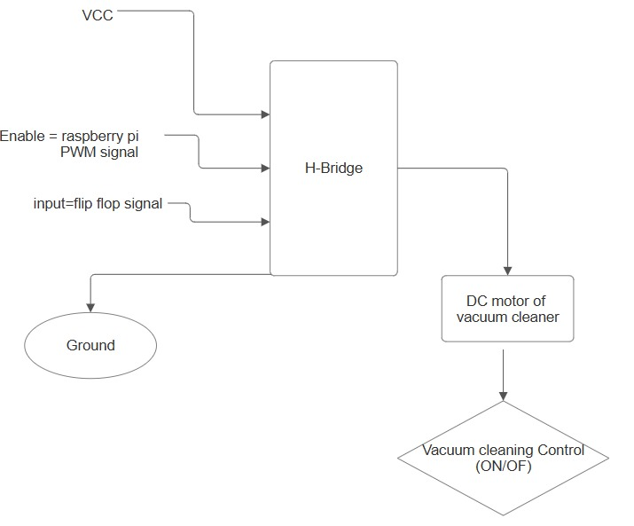

Figure Vacuum cleaning circuit

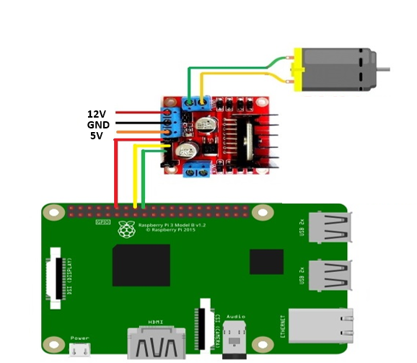

Figure Vacuum Cleaner real circuit.

* A signal asks the vacuum cleaner to be turned on
* This signal comes from the raspberry pi GPIO pins in the code as follows: **GPIO.output(PIN, GPIO.HIGH)**
* This GPIO pin is connected as input to the flip flop
* The output of the flip flop changes from low to high and stays high (since flip flop is a memory element)
* The output of the flip flop is connected to the H-bridge and forces the DC motor to be on, turning on the vacuum cleaner.
* The output of the GPIO pin after that is low (0)
* We wait for another signal asking to turn off the vacuum cleaner.
* This signal comes again from the same GPIO pin as a high signal (1) using the same line of code: **GPIO.output(PIN, GPIO.HIGH)**
* This signal enters the flip flop and inverts the signal from high to low and remains low
* The output of the flip flop is the input of the h-bridge which forces the DC motor to turn off.
* The output of the GPIO pin is low (0)
* And so on…

Details behind the hardware choices and implementation are presented below:

### Rover and Chassis

In our case we have settled on the use of turtlebot3, which is the most recent version of the turtlebot. This robot is known for being small, easy to use, programmable with Python and Matlab, and fully compatible with ROS [31]. The turtlebot we are using supports the use of Raspberry pi 4 model B, and the use of ROS2.

Turtlebot3 in our case is used as a rover to navigate through the environment of the hospital, using its wheels present at its base that are driven by the built-in DC motors. However, here it is essential to make a choice between two different types of the turtlebot3, which are the ‘Burger turtlbot3’ and the ‘Waffle turtlebot3’. Both types have the same software specifications from supporting ROS2 and the use of raspberry pi 4 model B, yet they differ in their structure, their design, and their design constraints. [31] has provided a comparison between both types and is shown in the table below:

Table Difference between turtlebot models [31]

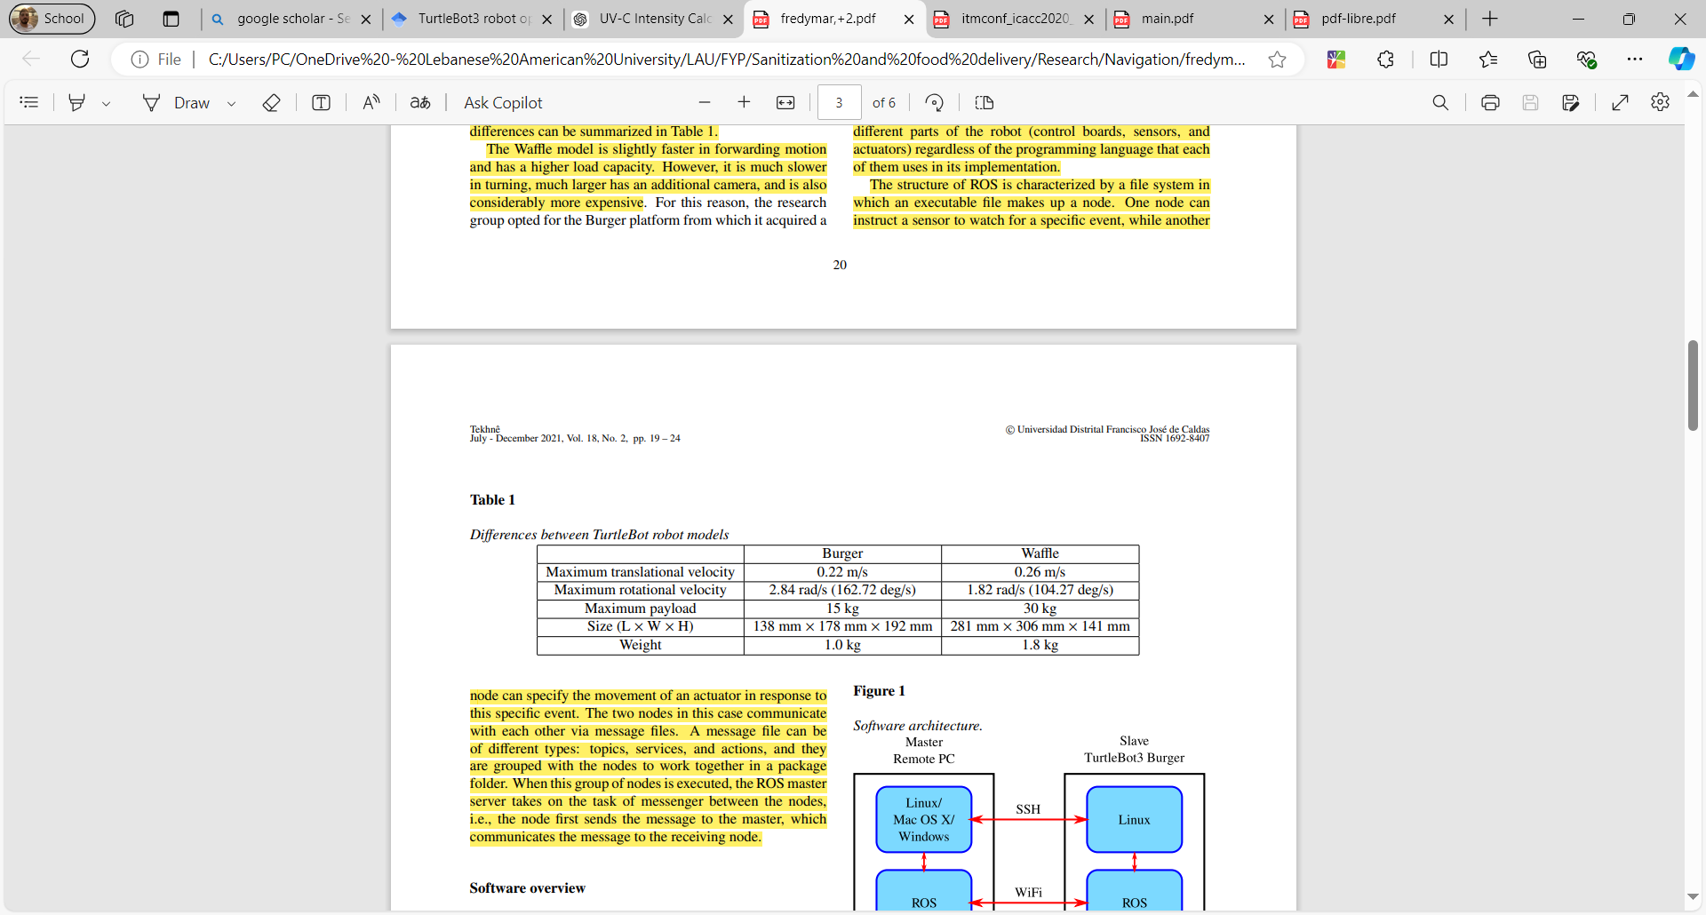

And as a matter of showing the shape/design of each model:

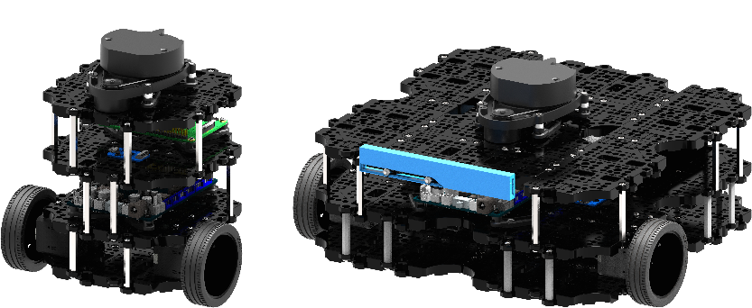

Figure Burger and Waffle turtlebot3 [32]

The robot on the left is the burger turtlebot3, and the one on the right is the waffle turtlebot3.

In our case we use the burger turtlebot3 to develop the project. The reason behind this is that the maximum payload held by it is 15 kg as shown in the table of comparison between the two, which is more than enough in our case as we intend to build a prototype. Another thing to note is that even though the size of the waffle turtlebot might be more suitable, however, layers cannot be built on top of the robot in order to provide a layer for delivery, a layer for power housing, a layer for circuitry, a layer to place the vacuum cleaner, and a layer for the LIDAR. The waffle only has three layers which are one for power housing, another for circuitry and the third for LIDAR leaving no space for the other features. On the other hand, the burger turtlebot allows building layers which suits our application.

### LiDAR Sensor

The turtlebot used is equipped with a 360 $°$ lidar sensor used for navigation and localization. The lidar sensor works by emitting infrared rays in the space and then the rays bounce back to the lidar. The mapping is done by calculating the time needed for the rays to be caught back by the lidar, with this the robot estimates where the obstacle is present and how far it is.

The lidar sensor in our case is to be placed on the very top of the robot without having any cover around it or above it as this causes severe errors and noise to the mapping of the system.

### Raspberry pi 4 model B

The turtlebot is equipped with a raspberry pi 4 model B, which is able also to work synchronously with the robotic operating system (ROS).

The raspberry pi might be essential in our case in order to integrate additional sensors to the system that collect data and synchronize with the whole robot. Another essential need might be the creation of an AI model that relies on the camera of the raspberry pi. This AI model is to be used in our case for debris/dust detection that signals the working of the vacuum cleaner.

### Vacuum cleaner components

To build the vacuum cleaner described in Figure 16, the needed components are:

* DC motor
* Fan blades
* Filter
* Container (in our case a bottle)
* A pipe that concentrates the sucking mechanism of the vacuum cleaner

As explained earlier, when the vacuum cleaner is on, the DC motor rotates and the aerodynamics of the system cause pressure difference between outside and inside (the pressure outside is greater than pressure inside), causing air to be sucked from out to in. The filter is placed just in front of the DC motor and collects all the dust and debris. The organization of those components is shown in fig. 18 below:

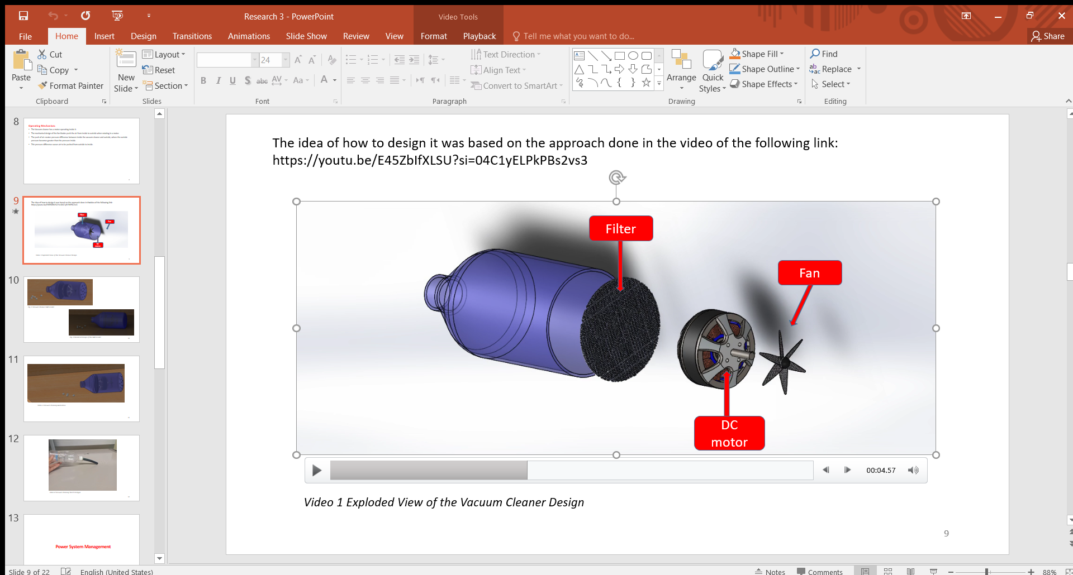

Figure Components of the built vacuum cleaner on Solidworks

To ensure that the designed vacuum cleaning is working, it was built and was found to work properly. It is important to note that we do not intend to enhance the sucking of the vacuum cleaner, since the project built in this phase aims to mesh the navigation, sanitization, and delivery all together in one robot. Enhancing the sucking of the vacuum cleaner could be done in real life by using a vacuum cleaner that consumes more power for more efficient cleaning.

### UV-C lights

We settle on using the UVC lights as UVC LEDs in the continuous mode as elaborated. The real UVC LEDs are present as bulbs as in Figure 19:

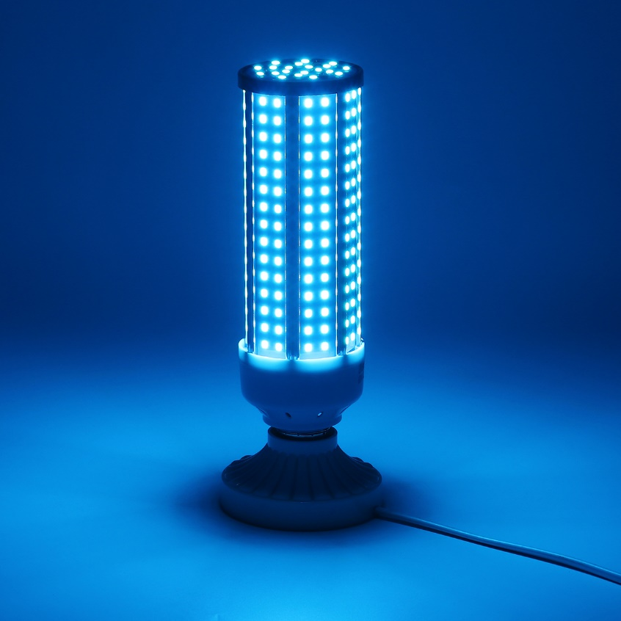

Figure UV-C LED Bulb [33]

Or as LED strips as in Figure 20:

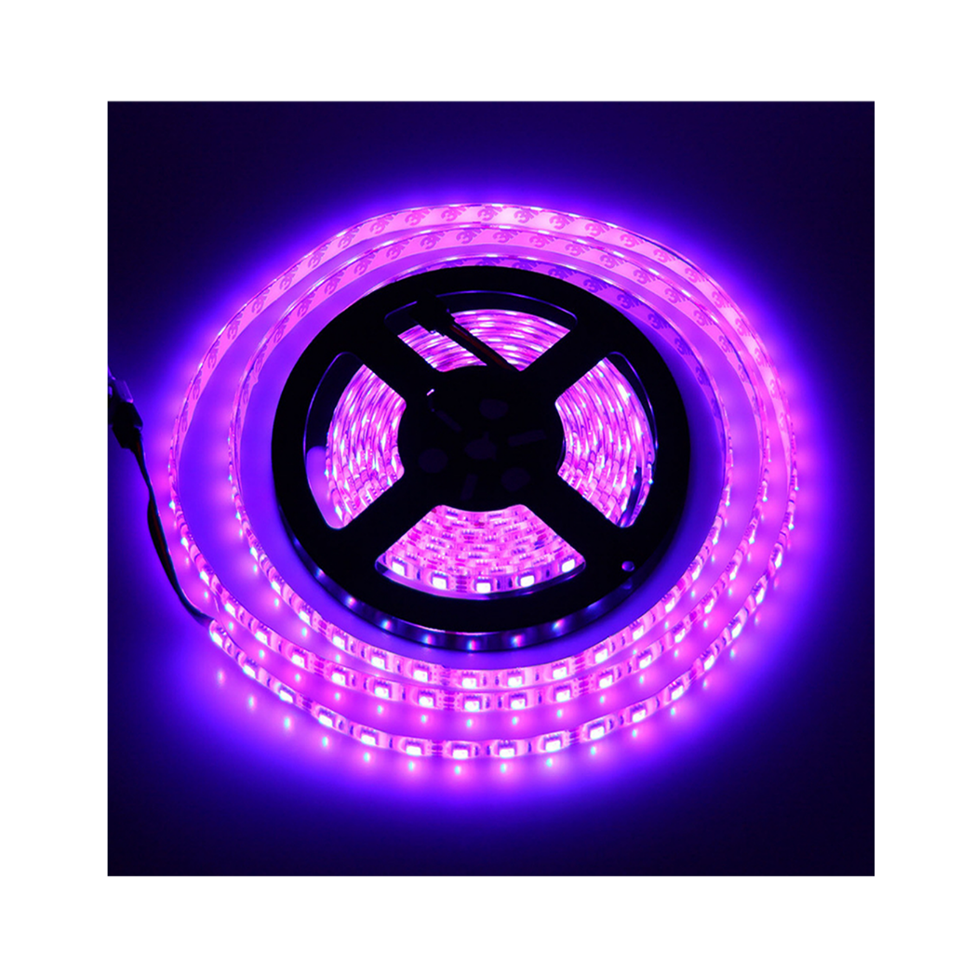

Figure UVC LED strips [34]

In our case, since we are building a prototype we use simple lamps to be placed surrounding around the robot. The lamps we consider using are the fluorescent light bulbs. The light bulbs are placed on the sides of the robot without being too tall to interfere with the LIDAR sensor signals or hit the ground.

The UVC LEDs we aim to buy and use have the following structure:

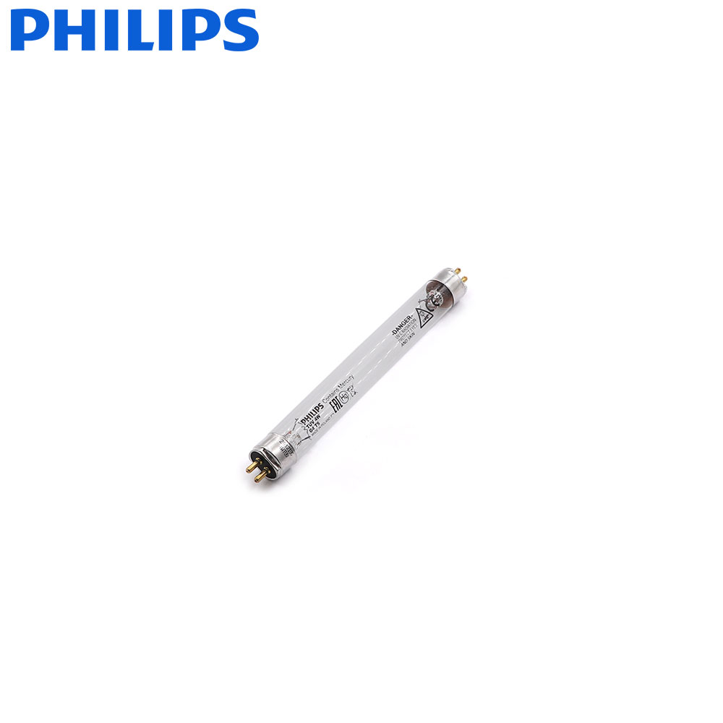

Figure UVC LEDs used in project

### LDR sensor

An LDR sensor is to be used for the delivery task. The LDR is an acronym of Light Dependent Resistor. This resistor is affected by light, where its resistance decreases as light intensity increases and vice versa.

The LDR sensor looks as follows:

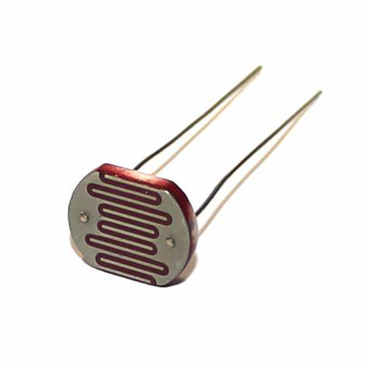

Figure LDR sensor [35]

Before doing the delivery there is no tray placed. If delivery need to be done, the tray is placed on the turtlebot in its corresponding layer. The base of the layer is acquired with LDR sensor(s). When the tray is placed for the delivery task to be handled, the LDR signals a change in its resistance since the light above it has changed. This change of the light is behind covering the LDR with the tray which is placed above it. When the robot reaches its destination of the delivered items, the tray should be removed, and with this the LDR sensor receive more light signaling a change in its resistance. This change in resistance then allows the robot to know that the delivery task was handled successfully and it can leave the room.

### Pi Camera

In our project an AI model is to be trained to detect debris or dust in order to turn on the vacuum cleaner. This detection is made by real time computer vision using the Pi Camera connected to the raspberry pi 4 model B in our case.

We still did not decide on a dataset to train the model with, in case no suitable dataset was found we decide to generate our own synthetic data by capturing pictures and saving them to the raspberry pi, labeling them as ones having dust and ones that do not, and in case there is dust/debris mark them on the images for efficient training.

The Pi Camera is usually separate from the raspberry pi and is bought then hooked to the pi.

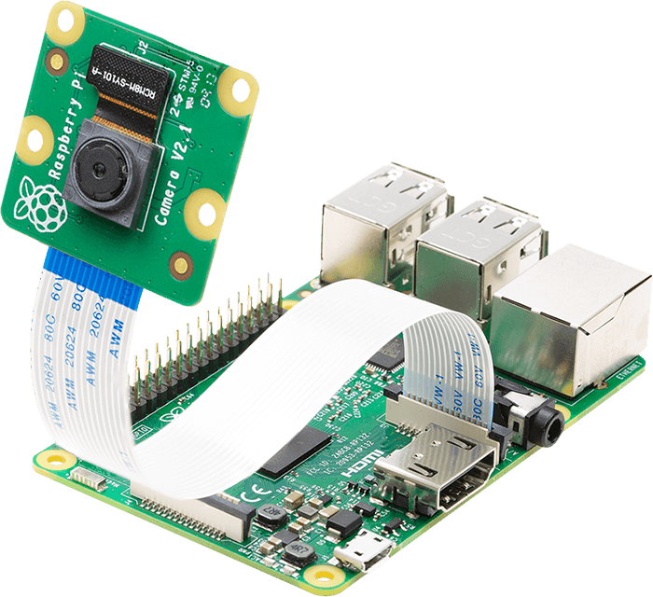

Figure Raspberry pi 4 model B with its camera [36]

In general, OpenCV library is the library used for computer vision opening the camera in real time and allowing the application of image processing. As for the AI model it cannot be specified which libraries are to be used exactly to build them, however among the most essential libraries is Scikit-learn used to make preprocessing, splitting data between training and testing, and for evaluation metrics. Since the application also involves dealing with images and pixels then the use of tensorflow/keras is also essential for building neural networks. Even the use of Pytorch could be an option. Other libraries might be handy such as Numpy, pandas, seaborn, and matplotlib when dealing with data.

### Power system

The turtlebot has already with it Lithium Polymer (LiPo) battery. It is preset as 3 cells placed in series. This battery has the following specifications:

* Voltage: 11.1 V
* Capacity: 1800mAh
* Max discharge rate: 9A
* Rechargeable

This battery is responsible of powering the turtlebot as a whole from powering the DC motor that move its wheels and chassis, to powering the LIDAR sensor, as well as powering the raspberry pi. It is estimated that this battery can power the robot for up to 1 hour.

On the other hand, looking onto our system, the robot has to power several newly introduced components other such as UVC LEDs (a minimum of 4 is to be used), a DC motor for vacuum cleaning, an LDR sensor, a camera for the raspberry pi, and a servo motor for the sprinkler used to dispense solution to mop the floor. The power supplied by the turtlebot might not be enough to power all of the following by the time, we need them all to be powered together. Not only this, we want them all to be working synchronously since for example the data provided by the camera is connected to the AI model that will give instructions whether to operate the vacuum cleaner or not, and also the lidar sensor is used for the whole navigation process etc...

As to address this issue additional batteries are used, and the synchronization is achieved by introducing flip flops to the system.

In our case we specify the lowest layer in the turtlebot as a space for the whole power system.

### Flip flops

Flip flops are essential components in sequential circuits, where the output depends on both the current inputs and the previous state.

In our case, the flip flops used play a simple role of inverting the provided signal once they are triggered. For instance, if a high signal is transferred to the flip flop, the flip flop should give an order for an electronic component to stay on. If the flip flop receives another high signal, it should give an order opposite to what was given before, that is to give an order for the electronic component to turn off and stay off. So the flip flop’s work we are interested in is a toggle switch that saves memory within it.

We aim to introduce flip flops as mentioned before, in order to use external battery for the system, yet to have synchronous work between all the parts. For example, the DC motor of the vacuum cleaner is to be controlled by the action of flip flops and powered by an external battery. The working principle in this case would be as follows:

* A signal asks the vacuum cleaner to be turned on
* This signal comes from the raspberry pi GPIO pins in the code as follows: **GPIO.output(PIN, GPIO.HIGH)**
* This GPIO pin is connected as input to the flip flop
* The output of the flip flop changes from low to high and stays high (since flip flop is a memory element), turning on the vacuum cleaner
* The output of the GPIO pin after that is low (0)
* We wait for another signal asking to turn off the vacuum cleaner
* This signal comes again from the same GPIO pin as a high signal (1) using the same line of code: **GPIO.output(PIN, GPIO.HIGH)**
* This signal enters the flip flop and inverts the signal from high to low and remains low, turning off the vacuum cleaner

With this we have introduced the flip flop into the system, however, in order to power the vacuum cleaner using an external power supply independent of the LiPo battery, we use in this specific case an H-bridge, namely the L293D.

As for the mopping mechanism, also the flip flop is used in a similar manner. The mopping mechanism works in a way such that the GPIO pin receives an input signal from the flip-flop to turn the pump on or off. The pump is activated through a relay in a way that the GPIO sends a high signal to the relay module which allows the power to flow to the pump and water is dispensed onto the sponge (the pump remains ON for 3-4 seconds). After that the GPIO sends a LOW signal to turn the relay switches OFF which prevent the power to flow in the pump (it remain in this state for 1-2 seconds). This ON-OFF cycle repeats as the robot moves across the room until it finishes all the room. Sending a high and a low signal to the GPIO is controlled by the flip-flop circuit which acts as a timer to generate square wave pulses for controlling the pump’s ON-OFF cycle through the GPIO pins.

### H-bridge

The structure of the H-bridge is as follows:

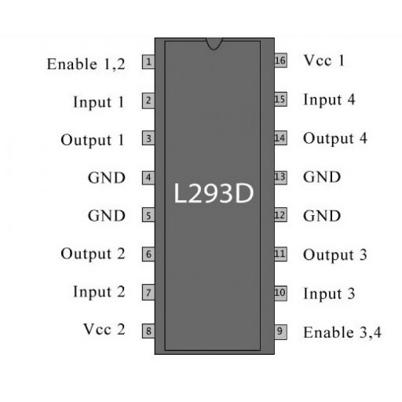

Figure L293D H-bridge pins [37]

This H-bridge can sustain up to 2.5 A current which is more than enough to handle the work of the DC motor used, since we are working in a prototype and not on a large scale project. This H-bridge can be used to drive 2 motors, however, we use it to drive one DC motor in our case which is for the vacuum cleaner.

The connections with the motor are done as follows:

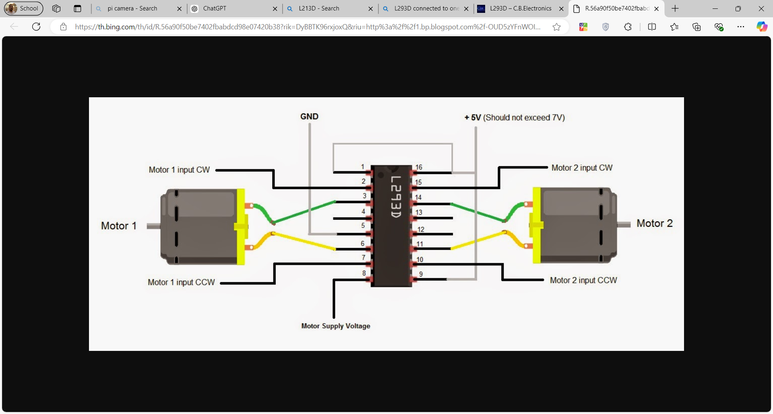

Figure Connections of the DC motor with L293D

We focus on the connections of one motor in our case. As it can be seen that pins 3 and 6 are connected to the DC motor. Pin 2 is the input responsible of the clockwise rotation, and pin 6 is the input responsible of counter clockwise rotation. For our project, we are interested only in turning the motor on and off, and not controlling the direction, thus, we may leave one of the inputs connected to the ground. The other input is connected to the output of the flip flop. In this case, the signal outputted from the flip flop is fed to the H-bridge, and the H-bridge will drive the motor. Regarding the power supplied to the DC motor, it is from the pin 16, which is Vcc1 and the GND. So the external battery can be connected to Vcc1 and GND of the h-bridge in order to power the DC motor, and by the use of the flip flop, the DC motor is working synchronously with the whole system. Thus, the actual steps happening are:

* A signal asks the vacuum cleaner to be turned on
* This signal comes from the raspberry pi GPIO pins in the code as follows: **GPIO.output(PIN, GPIO.HIGH)**
* This GPIO pin is connected as input to the flip flop
* The output of the flip flop changes from low to high and stays high (since flip flop is a memory element)
* The output of the flip flop is connected to the H-bridge and forces the DC motor to be on, turning on the vacuum cleaner
* The output of the GPIO pin after that is low (0)
* We wait for another signal asking to turn off the vacuum cleaner
* This signal comes again from the same GPIO pin as a high signal (1) using the same line of code: **GPIO.output(PIN, GPIO.HIGH)**
* This signal enters the flip flop and inverts the signal from high to low and remains low
* The output of the flip flop is the input of the h-bridge which forces the DC motor to turn off
* The output of the GPIO pin is low (0)
* And so on…

### Relays

The relay is an electromagnetic switch that allows a low power control signal from a microcontroller in our case raspberry pi to control high power signal. It takes a low voltage signal from the Gpio pin from Raspberry Pi in order to control the flow of electricity supplied from the external power source which in our case is VCC terminal in TurtleBot power board.

Usage in the UV-C case: The Gpio pin from the raspberry pi is connected to the relay to control the low power signal to activate or deactivate the relay. The relay is also connected to AC power supply and when activated the UV-C lights are turned ON

Usage in the Mopping mechanism case: The Gpio pin from the raspberry pi is connected to the relay to control the low power signal to activate or deactivate the relay. The relay when activated it will supply the water pump with DC power supplied from the VCC terminal in TurtleBot power board in order to pump water.

## Software Plan

### **a. Integration of AI-Based Dust Detection with Raspberry Pi**

This section outlines how a deep learning model trained for dust detection was integrated into an embedded system using a Raspberry Pi. The system utilizes a webcam for real-time video capture, a trained Convolutional Neural Network (CNN) model for classification, and GPIO pins for triggering a cleaning mechanism (vacuum cleaner). This fusion of artificial intelligence and embedded hardware enables intelligent, autonomous sanitization in real-world environments.

#### **1. Model Architecture and Setup**

For the dust detection task, a **ResNet-18** architecture was used due to its balance between performance and computational efficiency, making it suitable for edge devices such as the Raspberry Pi

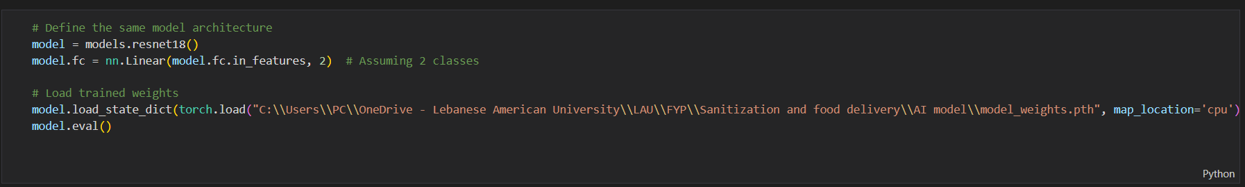

* models.resnet18(weights=None): Initializes the ResNet-18 model **without pre-trained weights**, as the model has been fine-tuned separately on a custom dataset for dust classification.
* model.fc = nn.Linear(...): Replaces the final fully connected layer with one that outputs predictions for two classes: ["clean", "dust"].
* model.load_state_dict(...): Loads the trained model weights from a .pth file.
* model.eval(): Puts the model in evaluation mode, disabling layers such as dropout and batch normalization in training mode to ensure consistent inference behavior.

The model was trained on labeled image data, distinguishing between clean surfaces and dusty ones. The training process was conducted on a high-performance machine, and the resulting parameters were exported and transferred to the Raspberry Pi for deployment.

#### 2. Preprocessing Pipeline

Before passing frames to the model, they must undergo preprocessing to match the input format expected during training.

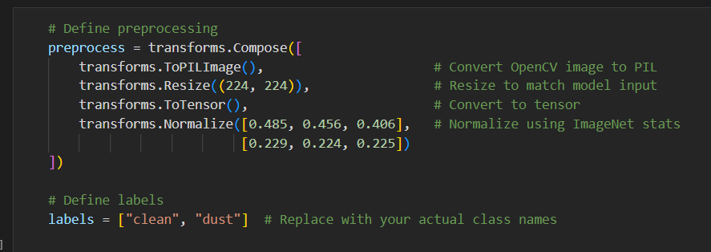

* **Resize**: Ensures that all images are scaled to 224x224 pixels, which is the standard input size for ResNet architectures.
* **ToTensor**: Converts the image to a PyTorch tensor with channels in the correct order.
* **Normalize**: Applies ImageNet mean and standard deviation normalization, as these statistics were used during model training.

This step is crucial to ensure that input images are interpreted correctly by the model and that inference results are accurate and consistent.

#### **3. Real-Time Video Frame Processing**

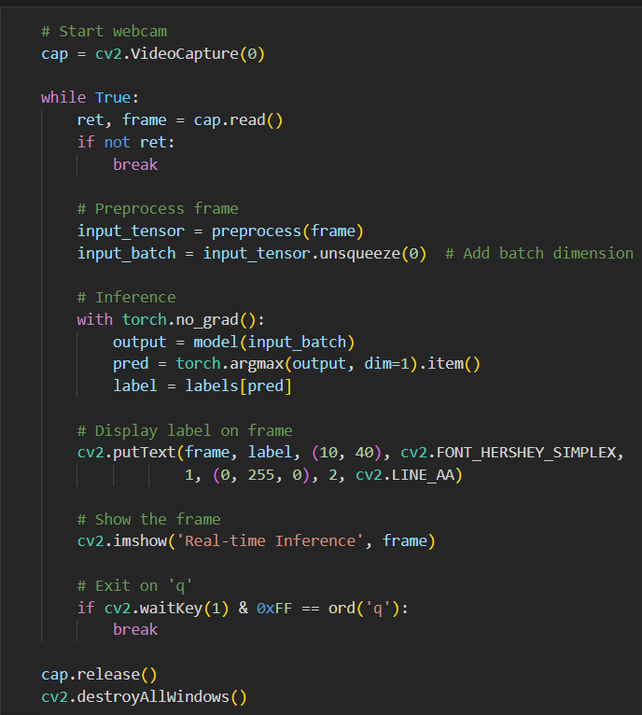

* The **webcam is initialized** using OpenCV to capture live video.
* Each frame is:
  + **Converted to RGB**, as OpenCV captures in BGR.
  + **Converted to a PIL image**, compatible with torchvision transforms.
  + **Preprocessed and reshaped** into a 4D batch tensor using unsqueeze(0).

This real-time stream provides continuous visual input to the model, which classifies each frame on-the-fly.

#### **4. Inference and Prediction**

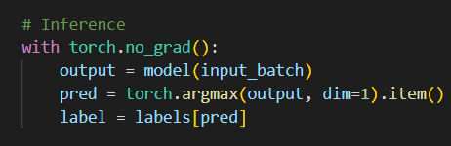

* **torch.no_grad()** disables gradient computation to improve performance and reduce memory usage during inference.
* **output = model(input_batch)** passes the frame through the model.
* **argmax** returns the class with the highest confidence score.
* The result is mapped to a human-readable label ("clean" or "dust"), which is then displayed.

The prediction is overlayed on the original frame for user feedback using cv2.putText

#### 5. Raspberry Pi GPIO Configuration

To enable the model to physically act on the prediction, the Raspberry Pi’s GPIO pins are used to trigger a cleaning mechanism (e.g., a vacuum cleaner via a relay).

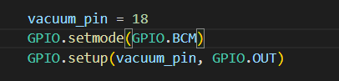

• GPIO **18** is configured as a digital output.

• A **relay module** is connected to this pin, which safely switches the vacuum motor on and off.

• The **BCM numbering** is used, referencing the GPIO pin number rather than the physical pin.

#### 6. Triggering the Cleaning System

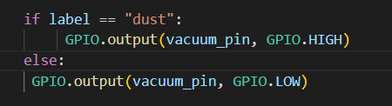.

* If the prediction is "dust", a HIGH signal is sent to activate the vacuum.
* If the prediction is "clean", a LOW signal turns it off.

This enables the system to autonomously react to environmental conditions without human intervention.

**Model Evaluation:**

To assess the performance of the AI model developed for dust detection, we conducted a training and evaluation process using a custom dataset consisting of labeled floor images classified as either "clean" or "dusty". The model was trained over a series of epochs and monitored using key performance metrics: training accuracy and training loss.

#### **Training Accuracy and Loss**

As shown in Figure below, the model’s performance steadily improved over the course of five epochs:

* The **training accuracy** increased from approximately **89.5%** at epoch 0 to **96.5%** by epoch 4.
* Simultaneously, the **training loss** decreased from **0.25** to below **0.08**, indicating effective learning and convergence of the model.

These metrics demonstrate that the model successfully minimized classification errors and adapted well to the training data without overfitting, as evidenced by the smooth and consistent learning curves.

#### **Test Performance**

After training, the model was evaluated on a separate test set that was not seen during training. The resulting **test accuracy** was **96.1%**, confirming that the model generalizes well and maintains high prediction performance on unseen data.

This high test accuracy, coupled with low training loss and consistent training accuracy improvements, validates the robustness and reliability of the model for real-time dust detection applications.

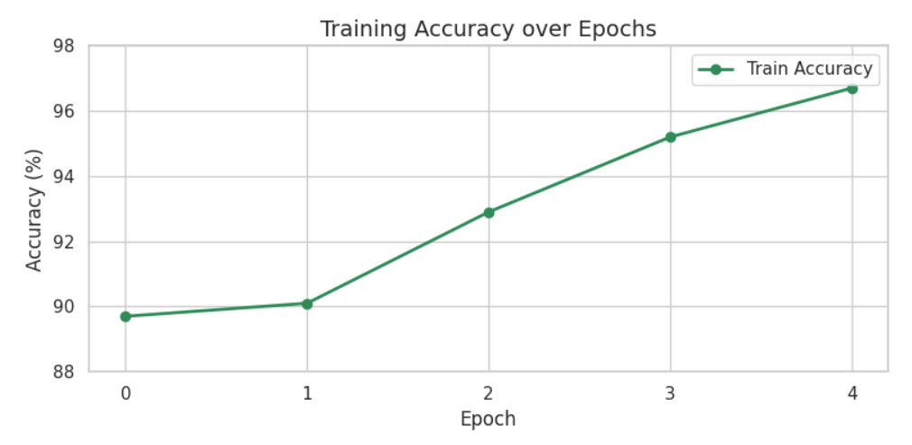

Figure Model Evaluation 1

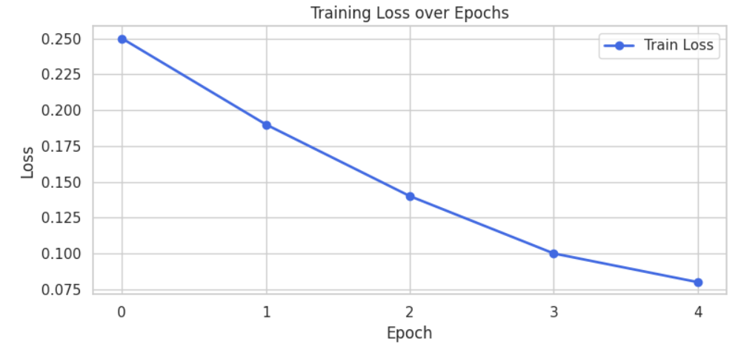

Figure Model Evaluation 2

#### Conclusion

This implementation demonstrates how an AI model can be successfully deployed on a Raspberry Pi for real-time environmental analysis. By combining computer vision, machine learning, and hardware control, this system achieves:

* Autonomous visual detection of dust.
* Real-time feedback via video overlay.
* Automated activation of a physical cleaning mechanism.

### Robotic Operating System (ROS)

ROS (Robot Operating System), which is a set of software libraries and tools, is an essential element in building robot applications. The variety of tools and libraries it provides help in executing many tasks like motion planning, sensor integration, and simulation in an easy way. ROS is organized as a distributed computing system that allows nodes to communicate with each other in a modular and scalable fashion using messages.

One of ROS’s attributes are its scalability where it provides support for modular design of the software, hence complex tasks can be partitioned into smaller programs called nodes. Also, it has built-in integration support for a wide for variety of sensors, motors, and controllers.

Moreover, ROS tools simplify the process of visualization and simulation using Rviz, for instance, which gives a way of viewing sensor data and the motion of the robot in real time, and Gazebo which provides a physics-accurate virtual platform for testing of algorithms before their deployment. ROS allows the running of tasks on multiple devices offloading computation-intensive tasks to servers, such as mapping and navigation.

Our project, as mentioned earlier, uses the TurtleBot3 burger, which is fully compatible with ROS, thus it is an ideal platform for autonomous navigation, mapping, and task execution. Some of ROS features that we will use in our project include:

### Localization and Mapping

* SLAM is used to enable a robot to explore an unknown environment while simultaneously creating a map of it autonomously.
* LIDAR Sensor: Generates laser scan data for mapping and detecting obstacles.
* Wheel Encoders: Provide data for tracking the movement of robots.

### Simulation using Gazebo

* Gazebo can simulate real-world environments in order to test hardware.
* This is able to model the exact physical properties such as forces, inertia, sensor data accurately.

### Rviz Visualization

* It visualizes the sensor data and shows Robot Trajectories and real time mapping of navigating environments.
* Allows to visualize how the robot is navigating in the environment in real time.
* It aids in the debugging and validation that may take place during the SLAM performance.

### Node and Message Passing

* ROS utilizes the publisher-subscriber model and enables communications between different components. (for instance: a publisher node publishes LIDAR data and a subscriber node processes these data to be used in obstacle detection and mapping)
* The nodes are managed by the ROS Master, which is keeping track of the list of currently active components of the system, to guarantee that they work uniformly.

Note that since the Raspberry Pi 4 on the TurtleBot3 has limited processing power, computationally intensive tasks such as SLAM are offloaded to an external computer or server using ROS's distributed system. The communication is handled over Wi-Fi, ensuring seamless integration between the robot and external systems for tasks like mapping and path planning.

As mentioned above, we will be simulating the turtlebot3 using ROS and gazebo to better understand its structure, parts, and movement in a real world scenario before buying it and adding our hardware components to it.

### ROS2 Deployment

To do that we installed ROS2 humble, gazebo, and all necessary packages for turtlebot3. Then we start by opening the terminal (we are working on Ubuntu 22.04) and loading the ROS2 and turtlebot3 environments using the command:

**source /opt/ros/humble/setup.bash**

then we specify the type of turtlebot3 model we are using by the command:

**export TURTLEBOT3_MODEL=burger**

we can make it permanent by adding the line:

**echo "export TURTLEBOT3_MODEL=burger" >> ~/.bashrc**

**source ~/.bashrc**

To view the turtlebot3 in an empty world we can use the command:

**ros2 launch turtlebot3_gazebo turtlebot3_world.launch.py**

by that gazebo loads and we can see the below model:

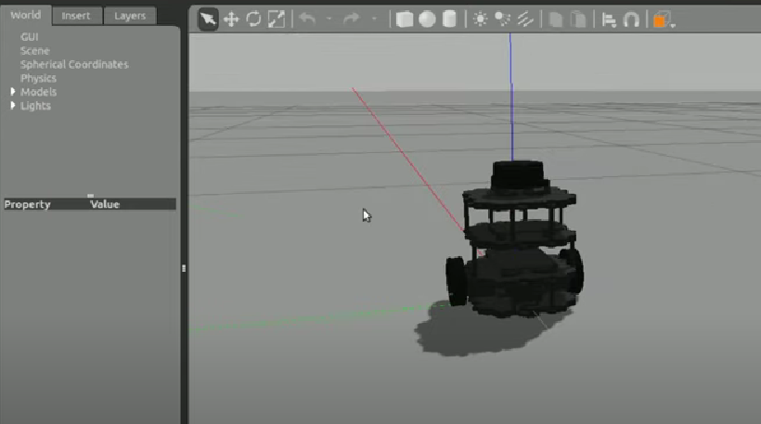

Figure Turtlebot3 deployment on gazebo

A much more interesting and beneficial step would be simulating the robot in a predefined room environment (with obstacles) to simulate a real world scenario. That is done by the command:

**ros2 launch turtlebot3_gazebo turtlebot3_house.launch.py**

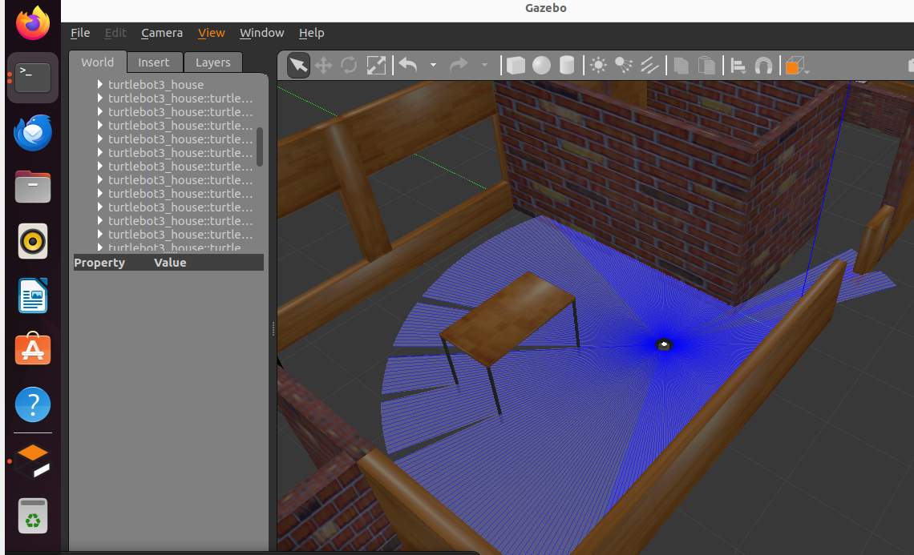

Figure Turtlebot3 insertion in an environment and data collection

Here, the blue circle around the robot represents the lidar sensor signals.

In order to move the robot in the room we add the command:

**ros2 run turtlebot3_teleop teleop_keyboard**

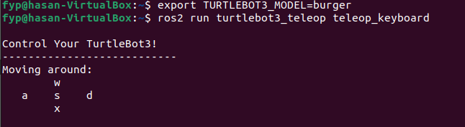

Figure Defining navigation method

Using these commands, we can move the robot in our room and visualize how the lidar sensor responds when being close to obstacles.

**Remark:** The defined method of navigation in Fig. 28 is using the keyboard keys. This is just a 1st step as a matter of getting more familiar with gazebo and knowing how to move the turtlebot. The final aim of the project is to let the robot navigate through the environment autonomously and alone.

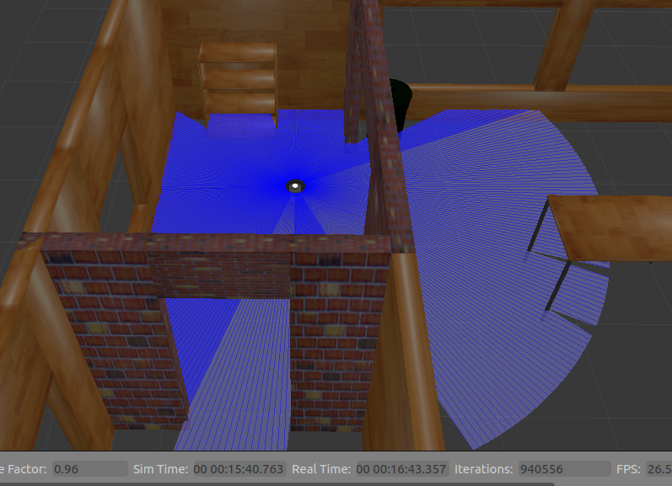

Figure Controlling the motion of the robot using the keyboard keys

We can simply take the robot where we need by changing the linear and angular velocities of the robot using the w, a, d, and x keys.

As a next step, we will try to make the robot move autonomously using SLAM. We start by sourcing the ROS2 environment and exporting the TurtleBot3 model as usual using the lines:

**source /opt/ros/humble/setup.bash**

**export TURTLEBOT3_MODEL=burger**

Then, we start SLAM (simultaneous localization and mapping) by:

**ros2 launch turtlebot3_cartographer cartographer.launch.py**

this opens Rviz and shows an empty map as the one in the below figure:

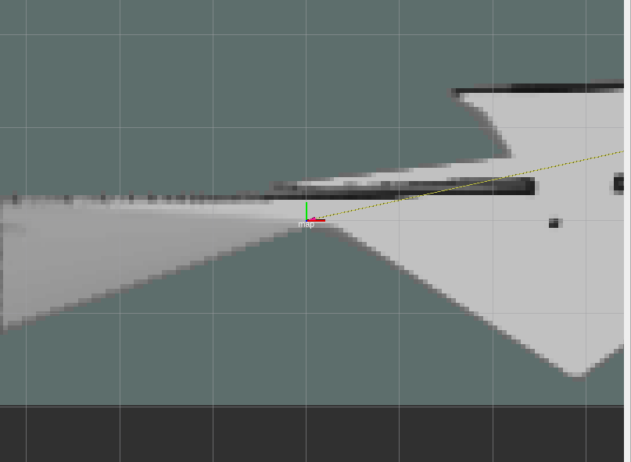

Figure image showing the map on rviz at initial state before navigation

We then move the turtlebot3 on the entire house to have the map updated on Rviz. The house is modeled as follows:

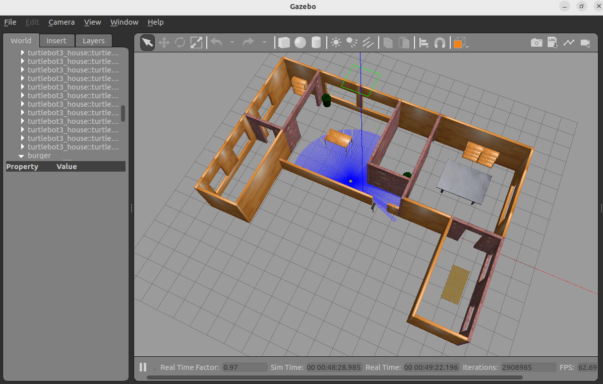

Figure image showing the entire world on gazebo

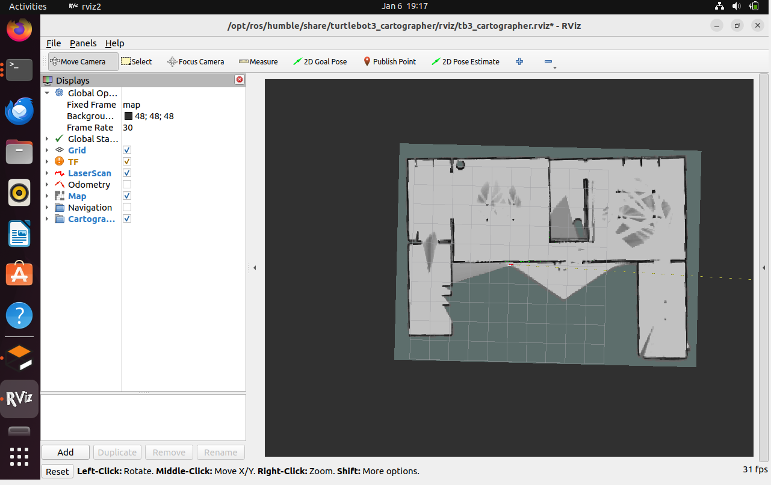

Figure image showing the updated map on Rviz after completing the navigation over the house

We can notice that the map is similar to our simulated world. Moreover, we can notice that obstacles are perfectly recognized (for example, the tables appear as 4 points resembling its legs)

After that we save the map using the command:

**ros2 run nav2_map_server map_saver_cli -f ~/map**

this command saves the two files: map.yaml and map.pgm in our home directory

After that, we launch the navigation stack with the saved map using the command:

**ros2 launch turtlebot3_navigation2 navigation2.launch.py use_sim_time:=true map:=/home/fyp/map.yaml**

Finally, to make the robot move autonomously we launch rviz using **ros2 launch turtlebot3_navigation2 navigation2.launch.py** andthe final step is to set the initial pose (pose estimate) which shows the robots starting position and orientation, and set the navigation goal which indicates the goal position and the direction where the robot should move to.

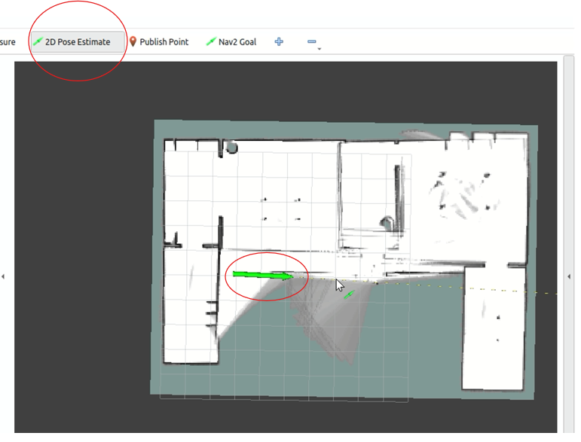

Figure image of setting pose estimate

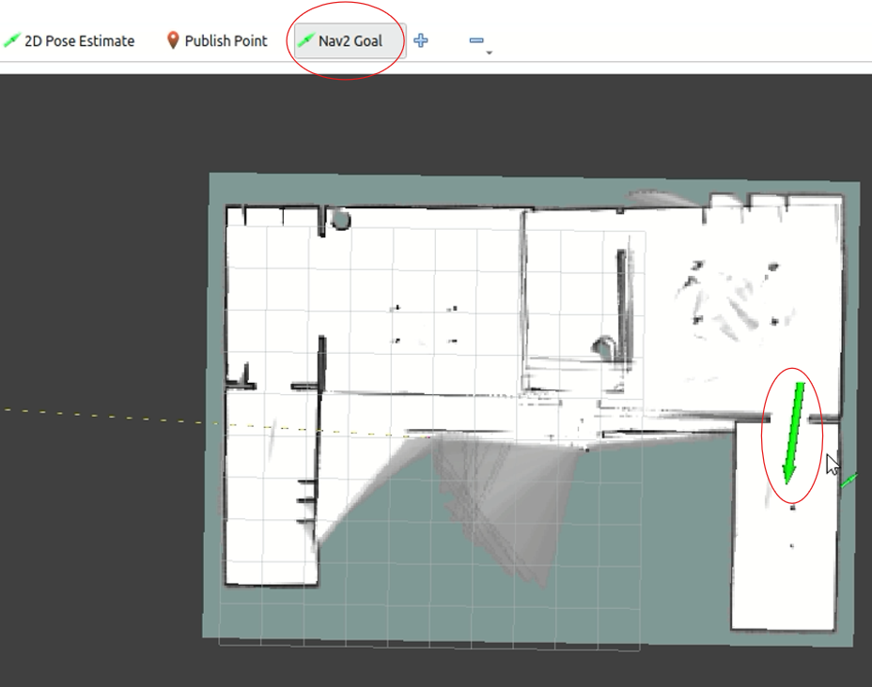

Figure image of setting the navigation goal

After that we can look at gazebo to watch the robot moving from its initial position to its goal.

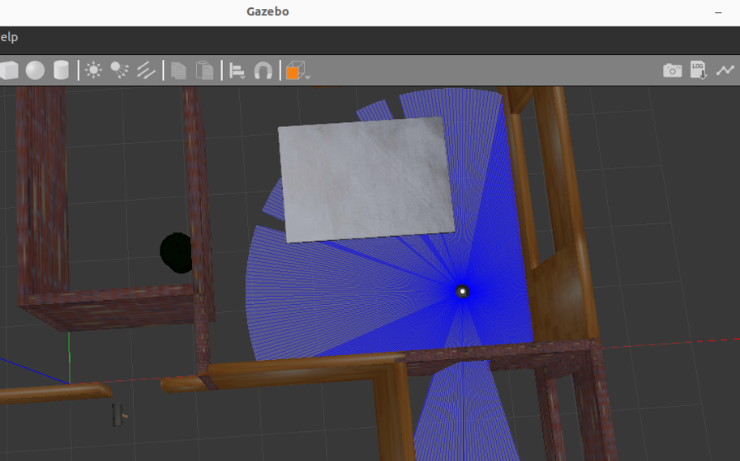

Figure robot reaching its navigation goal on gazebo

### AI Model:

This project integrates an AI model running on a Raspberry Pi 4 with the Pi Camera for real-time dust and debris detection, and the openCV library for image processing and object detection. The vacuum cleaner will be dynamically actuated by this system according to the output of the AI model. Also, this system detects human presence in order to switch off the UV-C lights for safety during operation. We create a Convolutional Neural Network (CNN) model designed to recognize dust and debris. The model is pretrained with images of various floor types (clean and dirty) to categorize the environment. OpenCV prepares the image by resizing, filtering, and converting it to grayscale for further analysis, then the AI model receives the processed image input, and predicts the presence of dust or debris.

According to that we update a variable we initialized in our code:

**dust_detected = true** 🡺 Surface is dirty.

**dust_detected = false** 🡺Surface is clean.

Next, if changes for this variable are detected from false to true, the vacuum cleaner will be activated, while if changes are detected from true to false, the vacuum cleaner will shut down. If the detection remains unchanged, the vacuum cleaner's state stays the same. This system makes sure the vacuum cleaner functions only when required, saving energy and enhancing cleaning efficiency.

On the other side, the model will also detect any human presence for safety precautions. We develop another AI model using OpenCV and TensorFlow for detecting humans. The model identifies individuals by analyzing visual characteristics (pre-trained YOLO models could be used for better efficiency). If a human is identified, the variable **human_detected** is assigned a value of true. Else, **human_detected** is assigned a value of false.

* If **human_detected** is true, the UV-C lights will be switched OFF.
* If **human_detected** is false, the UV-C lights stay ON for disinfection.

This system avoids exposure of humans to UV-C light, reducing health hazards like eye injuries and skin burns. The ROS framework incorporates both AI models (dust/debris detection and human presence detection) as distinct nodes:

• Node 1: The node responsible for detecting dust and debris broadcasts the **dust_detected** variable.

• Node 2: The human presence detection node broadcasts the **human_detected** variable.

• Controller Node: Subscribes to both topics to appropriately manage the states of the vacuum cleaner and UV-C light.

This system will ensure many benefits to our project including enhancing the vacuum cleaner's usage, minimizing excessive operation, protecting humans from unintentional UV-C light exposure, complying with safety regulations, ensuring complete autonomy for robot by reducing the need for human input.

6. Final System

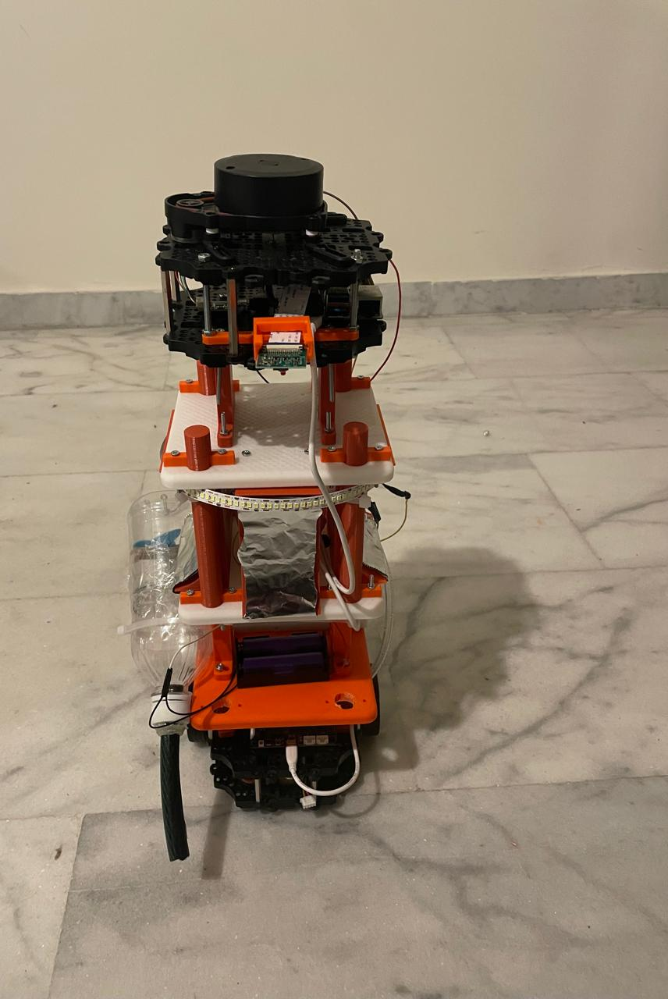

Figure Full Working Sysem

The final implemented system is a fully integrated **autonomous sanitization and delivery robot**, built on top of the **TurtleBot3 Burger** platform. The robot is designed to operate in indoor environments such as hospitals, navigating autonomously while performing both sanitization and delivery tasks with minimal human intervention. The layered design allows it to efficiently host multiple functionalities within a compact footprint.

#### **Hardware Integration**

The robot is physically structured in a **multi-layered format**, each layer dedicated to a specific subsystem:

* **Bottom Layer**: Hosts the TurtleBot3 base with differential-drive wheels and the onboard controller for mobility.
* **Intermediate Layers**: House the **Raspberry Pi 4**, motor drivers, relays, and power management circuits. These layers are also equipped with:
  + A **custom-built vacuum cleaner**, controlled by GPIO and powered via H-bridge.
  + A **water pump and mopping unit**, triggered through a relay circuit for wet cleaning.
* **Upper Layer**: Equipped with **UV-C lights** and a surrounding reflective surface (aluminum foil) to enhance disinfection coverage.
* **Top Layer**: Features the **LiDAR sensor**, used for real-time SLAM-based localization and mapping.

Each component is securely mounted and properly wired, ensuring robust operation even during long autonomous missions. Figure [XX] shows the fully assembled system.

#### **Software Integration**

The software architecture is based on **ROS2 (Robot Operating System)** for control and navigation, and **Python scripts** running AI inference models and GPIO control logic. The robot can:

* Autonomously navigate to user-defined goals via LIDAR-based SLAM.
* Perform **dust detection** using a trained **ResNet-18 CNN model** deployed on the Raspberry Pi.
* Based on visual classification results:
  + Turn on the **vacuum cleaner** if dust is detected.
  + Perform **mopping and UV-C disinfection** in sequential passes.
* Deliver food or medication using trays mounted on mid-level layers.

Each cleaning and delivery task is orchestrated automatically, and the robot can be monitored or supervised through a local terminal or remote interface.

#### **Conclusion**

The final robot presents a successful fusion of AI, embedded hardware, and robotics. It demonstrates the potential of autonomous systems in reducing human exposure to infectious zones while enhancing hygiene and operational efficiency in healthcare settings. The compact design, real-world testing, and modular construction make it an ideal prototype for future scale-up or deployment.



# 7.Constraints, Standards, and Cost

## Constraints

Table Table of Constraints

|  |  |  |
| --- | --- | --- |
| **General Constraints** | Deadline | The Project must be completed by the end of the Spring semester in 2025. |
| Scope | The robot is designed specifically for hospital environments, limiting its applicability to relatively smooth floors and indoor settings. |
| **Economic Constraints** | Cost | The project must remain cost-effective, using affordable materials like aluminum foil and self-built mechanisms over commercial products. |
| **Functional Constraints** | **Autonomous Operation** | * The robot must navigate autonomously without human intervention while switching between cleaning and delivery modes. * Some hospital staff should be supervising the work of the robot, and giving it instructions where to go and what to do. |
| Limited Delivery Mechanism | * The tray can deliver items that do not require any special packaging, those items should be decided by the hospital staff. * The robot normally does not carry on it a tray, the tray is manually put by hospital staff when something is to be delivered, and manually removed when receiving the item to be delivered. |
| Navigation | * The robot will not be doing simultaneous building of the map as well as localization, but rather the map of the environment is to be designed and its URDF file is to be given to the robot to train on it. * Localization and Mapping must function accurately in static hospital environments. |
| Surface Compatibility | The vacuum and mopping mechanisms are for smooth and hard floors, and may not perform well on carpets or uneven surfaces. |
| Path Planning | We do not intend to optimize the path planning algorithm followed by the robot, we intend having a fully working robot doing all its tasks properly. Optimization of the path planning of the autonomous navigating robot is considered a bonus task. |
| **Non-Functional Constraints** | **Size** | * ‘The UV-C LEDs should not be very tall to obstruct the information of the LiDAR or to touch the ground. * The vacuum cleaner should be small and fit inside the turtlebot. |
| Weight | The robot must remain lightweight (<12 kg). |
| Power Consumption | External batteries are added as to sustain the vacuum motor and UV-C lights without overloading the TurtleBot's main power supply. |
| Surrounding Environment | * The doors of the rooms the robot goes to are assumed to be connected by IoT to the robot, by which they open and close automatically when the robot enters or leaves. * All obstacles in the room are assumed to be captured by the LiDAR sensor, that is no very short obstacles are present in the room. |
| **Safety Constraints** | UV-C Light Safety | * UV-C disinfection works in areas where no humans are present. * Reflective surfaces like aluminum foil will direct UV-C light effectively while minimizing leakage. * If the robot senses the presence of humans while doing sanitization the UV-C lights turn off automatically. |
|  | Chemical Safety | Mopping liquids must be non-toxic and safe for hospital environments and materials. |

## Standards

To ensure the safety, efficiency, and reliability of the autonomous sanitization and drug delivery robot, the following standards are adhered to:

### Safety Standards

* **ISO 15858:2016**: UV-C equipment safety guidelines to ensure safe exposure levels for humans [38].
* **IEC 60335-2-69**: Safety of electrical appliances for cleaning, particularly those using UV-C or other chemical disinfectants [39].
* **Ozone Safety Standards**: Ensuring ozone-producing equipment is compliant with safety regulations for air quality and exposure limits [40].

### Medical and Pharmaceutical Standards

* **ISO 13485:2016**: Quality management for medical devices used in drug delivery [41].

### Autonomous Navigation and Robotics

* **ISO 3691-4:2020**: Safety requirements for autonomous mobile robots [41].

### Performance Standards

* **ISO 28199**: Standards for evaluating surface cleanliness and disinfection effectiveness [41].

### Environmental and Sustainability Standards

* **RoHS (Restriction of Hazardous Substances Directive)**: To ensure that the materials used in the robot are environmentally friendly [42].
* **ISO 14001:2015**: Environmental management systems to minimize ecological impact during operation [41].

## Cost Analysis

Table Table of components and costs

|  |  |
| --- | --- |
| **Components** | **Price (U.S. $)** |
| TurtleBot3 Burger model | 659.30 $ + shipping fees |
| 4 UV-C LEDs | 18.00 $/piece [43] |
| DC motor for vacuum cleaner | 5 $ |
| L293D H-bridge | 1.5 $ [44] |
| Flip flop | 0.4 $/piece [45] |
| External Batteries | 15 $ |
| Wires | 10 $ |
| Plastic PLA for 3D printing | 18 $/kg [46] |
| Pi Camera | 32 $ [47] |
| LDR | 1 $/piece [48] |
| Low LPM pump motor | 6.25 $ [49] |
| Tube for vacuum cleaner | 10 $ |
| Tube for sprinkler | 10 $ |
| 2 Relay | 2 $ [50] |
| DC to AC converter | 5 $ |
| Total | $≈850 \$$ |

# 7. Alignment with the Sustainable Development Goals (SDGs)

In line with LAU’s commitment to sustainable development, this project aligns with the following United Nations Sustainable Development Goals (SDGs) by addressing global challenges in healthcare and workplace safety.

## SDG 3: Good Health and Well-Being

**Target:** Ensure healthy lives and promote well-being for all at all ages.

* The project aims to do sanitization in hospitals using advanced techniques such as UVC sanitization. The used method relies on **UV-C LEDs** which do not emit ozone or mercury, making their use safer and non-toxic. The complete safety is ensured by having people not interfere the area where the robot is operating. If human presence was sensed, then the system is shut down completely.
* By operating in dangerous areas, the robot minimizes staff exposure to high-risk situations, such as biohazard zones or areas with chemical exposure, thereby enhancing workplace safety.

## SDG 8: Decent Work and Economic Growth

**Target:** Promote sustained, inclusive, and sustainable economic growth, full and productive employment, and decent work for all.

* The project is not aimed at replacing staff but at **enhancing their safety** and allowing them to focus on more critical and strategic tasks. This creates a safer work environment and improves productivity without compromising employment opportunities.
* By automating repetitive and high-risk activities, the robot enhances job quality and reduced time needed to deliver several tasks together, therefore reducing workplace stress, and contributing to employee well-being.

## SDG 9: Industry, Innovation, and Infrastructure

**Target:** Build resilient infrastructure, promote inclusive and sustainable industrialization, and foster innovation.

* Employing innovative solutions such as **UV-C LEDs**, autonomous navigation, and IoT connectivity, the project sets a benchmark for technology integration in robotics for healthcare and industrial applications.
* The robot supports the development of resilient healthcare systems, particularly in managing infection control in high-risk or hard-to-reach environments.

## SDG 12: Responsible Consumption and Production

**Target:** Ensure sustainable consumption and production patterns.

* Optimized use of cleaning agents and reduced dependency on disposable tools align with sustainable production and waste reduction goals.

## SDG 13: Climate Action

**Target:** Take urgent action to combat climate change and its impacts.

* By utilizing **ozone-free UV-C LEDs**, the project avoids the harmful environmental impacts associated with ozone production, ensuring a climate-friendly disinfection approach.

Reduced use of single-use materials and environmentally harmful chemicals contributes to lower greenhouse gas emissions and waste management.

## Other SDGs

Other SGDs tackle topics of hunger, poverty, gender equality, quality education, clean water and sanitation, affordable and clean energy, reduced inequality, sustainable cities and communities, responsible consumption and production, life below water, life on land, peace and justice, and partnerships for goals. Those SGDs are not correlated with our project, and still are none of them is broken by the work we aim to build. Therefore, the project designed and to be implemented commits to sustainable development.

# References

|  |  |
| --- | --- |
| [1] | J. M. Boyce, "Modern technologies for improving cleaning and disinfection of environmental surfaces in hospitals," *Antimicrobial Resistance and Infection Control,* vol. 5, pp. 0-10, 2016. |
| [2] | S. Perminov, N. Mikhailovskiy, A. Sedunin, I. Okunevich, I. Kalinov, M. Kurenkov and D. Tsetserukuo, "UltraBot: Autonomous Mobile Robot for Indoor UV-C Disinfection," in *IEEE 17th International Conference on Automation Science and Engineering (CASE)*, Lyon, 2021. |
| [3] | N. Demeersseman, V. Saegeman, V. Cossey, H. Devriese and A. Schuermans, "Shedding a light on ultraviolet-C technologies in the hospital environment," *Journal of Hospital Infection,* vol. 132, pp. 85-92, 2023. |
| [4] | M. Guettari, I. Gharbi and S. Hamza, "UVC disinfection robot," *Environmental Science and Pollution Research,* vol. 28, pp. 40394-40399, 2021. |
| [5] | A. R. Pereira, D. F. Braga, M. Vassal, I. B. Gomes and M. Simões, "Ultraviolet C irradiation: A promising approach for the disinfection of public spaces?," *Science of the Total Environment,* vol. 879, 2023. |
| [6] | A. Begić, "Application of Service Robots for Disinfection in Medical Institutions," in *In Advanced Technologies, Systems, and Applications II: Proceedings of the International Symposium on Innovative and Interdisciplinary Applications of Advanced Technologies (IAT)*, Springer International Publishing, 2018, pp. 1056-1065. |
| [7] | J. Hadi, M. Dunowska, S. Wu and G. Brightwell, "Control Measures for SARS-CoV-2: A Review on Light-Based Inactivation of Single-Stranded RNA Viruses," *Pathogens,* vol. 9, 2020. |
| [8] | S. K. Bhardwaj, H. Singh, A. Deep, M. Khatiri, J. Bhaumik, K.-H. Kim and N. Bhardwaj, "UVC-based photoinactivation as an efficient tool to control the transmission of coronaviruses," *Science of the Total Environment,* vol. 792, 2021. |
| [9] | F. J. Garcia de Abajo, R. J. Hernandez, I. Kaminer, A. Meyerhans, J. Rosell-Llompart and T. Sanchez-Elsner, "Back to Normal: An Old Physics Route to Reduce SARS-CoV-2 Transmission in Indoor Spaces," *ACS Nano,* vol. 14, no. 7, 2020. |
| [10] | R. C. She, D. Chen, P. Pak, D. K. Armani, A. Schubert and A. M. Armani, "Lightweight UV-C disinfection system," *Biomedical Optical Express,* vol. 11, no. 8, pp. 4326-4332, 2020. |
| [11] | W. Kowalski, "Mathematical Modeling of UV Disinfection," in *Ultraviolet Germicidal Irradiation Handbook: UVGI for Air and Surface Disinfection*, Springer Science & Business Media, 2010, pp. 51-70. |
| [12] | "Evaluation of germicidal ultraviolet-C disinfection in a real-world outpatient health care environment," *American Journal of Infection Control,* vol. 52, pp. 1030-1034, 2024. |
| [13] | L. F. White, D. S. J. Dancer and C. Robertson, "A microbiological evaluation of hospital cleaning methods," *International Journal of Environmental Health Research,* vol. 17, no. 4, pp. 285-295, 2007. |
| [14] | A. Dey and S. Hens, " Study on Steam Cleaning Devices and Its Impact on Health and Hygien," in *Applications of Artificial Intelligence in Engineering*, Springer, 2021. |
| [15] | P. Kolhe, S. Kale, P. pardeshi and D. Kadam, "Sanitize Spraying Wireless Robot For Quarantine Centers & Hospitals," *Journal Publication of International Research for Engineering and Management,* vol. 10, no. 4, pp. 1-6, 2022. |
| [16] | J. Smith, "Understanding the OxidativeMechanis of Ozone in Disinfection Processes," *Journal of Environmental Science and Health,* vol. 45, no. 3, pp. 315-322, 2020. |
| [17] | L. Davis, "Broad-Spectrum Efficacy of Ozone Gas as a Disinfectant," *International Journal of Hygiene and Environmental Health,* vol. 223, no. 2, pp. 204-211, 2019. |
| [18] | M. Rodriguez, "Challenges and Precautions in the Utilization of Ozone as a Disinfectant," *Jorunal of Industrial and Environmental Chemistry,* vol. 38, no. 4, pp. 455-460, 2021. |
| [19] | P. Jiang, L. Chen, H. Guo, M. Yu and J. Xiong, "Novel indoor positioning algorithm based on Lidar/inertial measurement unit integrated system," *International Journal of Advanced Robotic Systems,* vol. 18, no. 2, pp. 1-11, 2021. |
| [20] | X. Zuo, X. Xie, Y. Liu and G. Huang, "Robust Visual SLAM With Point and Line Features," in *IEEE/RJS International Conference on Intelligent Robots and Systems*, 2017. |
| [21] | K. Jha, A. Sakhare, N. Chavhan and P. P. Lokulwar, "A review on image enhancement techniques using histogram equalization," in *AIDE-2023 and PCES-2023*, 2023. |
| [22] | K. McAleer, "SLAM," kevsrobots, [Online]. Available: https://www.kevsrobots.com/resources/how_it_works/slam.html. |
| [23] | S. P. Thale, M. M. Prabhu, P. V. Thakur and P. kadam, "ROS based SLAM Implementation for Autonomous navigation using Turtlebot," in *ITM Web of Conferences* , 2020. |
| [24] | R. Maan, A. Madiwale and M. Bishoni, "Design and Analysis of ‘Xenia: The Medi-Assist Robot' for Foot Delivery and Sanitization in Hospitals," in *2nd Global Conference for Advancement in Technology (GCAT)*, Bangalore, 2021. |
| [25] | R. Bloss, "Mobile hospital robots cure numerous logistics needs," *Industrial Robot: An International Journal,* vol. 38, no. 6, pp. 567-571, 2011. |
| [26] | K. KRISHNAMURTHY, A. DEMIRCI and J. IRUDAYARAJ, "Inactivation of Staphylococcus aureus by Pulsed UV-Light Sterilization," *Journal of Food Protection,* vol. 67, no. 5, pp. 1027-1030, 2004. |
| [27] | K. Sholtes and K. G. Linden, "Pulsed and continuous light UV LED: microbial inactivation, electrical, and time efficiency," *Water Research ,* vol. 165, pp. 1-10, 2019. |
| [28] | B. Ma, S. Burke-Bevis, L. Tiefel, J. Rosen, B. Feeney and K. G. Linden, "Reflection of UVC wavelengths from common materials during surface UV disinfection: Assessment of human UV exposure and ozone generation," *Science of the Total Environment,* vol. 869, 2023. |
| [29] | P. d. S. Stojalowski and J. Fairfoull, "Comparison of Reflective Properties of Materials Exposed to Ultraviolet-C Radiation," *Journal of Research of the National Institute of Standards and Technology,* vol. 126, 2021. |
| [30] | M. R. Prajapati, "Youtube," [Online]. Available: https://youtu.be/E45ZbIfXLSU?si=04C1yELPkPBs2vs3. |
| [31] | F. H. Martínez, "TurtleBot3 robot operation for navigation applications using ROS," *Tekhnê,* vol. 18, no. 2, pp. 19-24, 2021. |
| [32] | E. Ackerman and E. Guizzo, IEEE Spectrum, [Online]. Available: https://spectrum.ieee.org/review-robotis-turtlebot-3. |
| [33] | "40w 80w ultraviolet germicidal lamp uvc led bulb," Banggood, [Online]. Available: https://ar.banggood.com/40W-80W-Ultraviolet-Germicidal-Lamp-LED-UVC-Bulb-Household-Ozone-Disinfection-Light-85-265V-p-1662907.html?akmClientCountry=LB&cur_warehouse=CN. |
| [34] | "UVC LED Flexi-Strip 270-280NM to Sterilise & Disinfect," JLEDS LED LIGHTING, [Online]. Available: https://jleds.co.uk/product/1320/. |
| [35] | "Light Dependant Resistor," Katranji Store, [Online]. Available: https://katranji.com/en/item/220730. |
| [36] | "Raspberry Pi Camera Pinout," ArduCam, [Online]. Available: https://www.arducam.com/raspberry-pi-camera-pinout/. |
| [37] | "L293D," CB Electronics, [Online]. Available: https://cb-electronics.com/products/l293d/. |
| [38] | ISO, 2016. [Online]. Available: https://www.iso.org/search.html. [Accessed 24 November 2024]. |
| [39] | IEC, 2024. [Online]. Available: https://webstore.iec.ch/. [Accessed 3 January 2025]. |
| [40] | Occupational Safety and Health Administration, [Online]. Available: https://www.osha.gov/. |
| [41] | "ISO: Global standards for trusted goods and services," ISO, [Online]. Available: https://www.iso.org/home.html. |
| [42] | "European Commission," 2021. [Online]. Available: https://environment.ec.europa.eu/topics/waste-and-recycling/rohs-directive_en. [Accessed 1 December 2024]. |
| [43] | Katranji Store, [Online]. Available: https://katranji.com/en/item/460418. |
| [44] | Katranji Store, [Online]. Available: https://bec-lb.com/products/dual-d-flip-flop-cd4013bcn?pr_prod_strat=e5_desc&pr_rec_id=a522d3827&pr_rec_pid=6841241370758&pr_ref_pid=6841243533446&pr_seq=uniform. |
| [45] | Beirut Electrocity, [Online]. Available: https://bec-lb.com/products/dual-d-flip-flop-cd4013bcn?pr_prod_strat=e5_desc&pr_rec_id=a522d3827&pr_rec_pid=6841241370758&pr_ref_pid=6841243533446&pr_seq=uniform. |
| [46] | Katranji Store, [Online]. Available: https://bec-lb.com/products/raspberry-pi-camera-8mp?srsltid=AfmBOoo_sJVGLLuw4c0m984_jlX3r-PslZgMUEZnZQ7iGECEdZkRYdUq. |
| [47] | Beirut Electrocity, [Online]. Available: https://bec-lb.com/products/raspberry-pi-camera-8mp?srsltid=AfmBOoo_sJVGLLuw4c0m984_jlX3r-PslZgMUEZnZQ7iGECEdZkRYdUq. |
| [48] | Beirut Electrocity, [Online]. Available: https://bec-lb.com/products/photosensitive-sensor-module-light-dependent-control-ldr?srsltid=AfmBOor7XRf6MNlmtSlkMEbqJXm6zFbGPNQ6usEyURsfG9yqVvRW-HRy. |
| [49] | Katranji Store, [Online]. Available: https://katranji.com/en/item/406195. |
| [50] | Beirut Electrocity, [Online]. Available: https://bec-lb.com/collections/relays?srsltid=AfmBOopLT-m_-srKrCrlzgAwthS4lUAgbufUQcZwhVbNSmgKHCb40L7q. |
| [51] | International Electrotechnical Commission, [Online]. Available: https://www.iec.ch/homepage. |